SUBCOURSE EDITION
MP1032 C

ENEMY PRISONER OF WAR (EPW) AND
CIVILIAN INTERNEE (CI) OPERATIONS

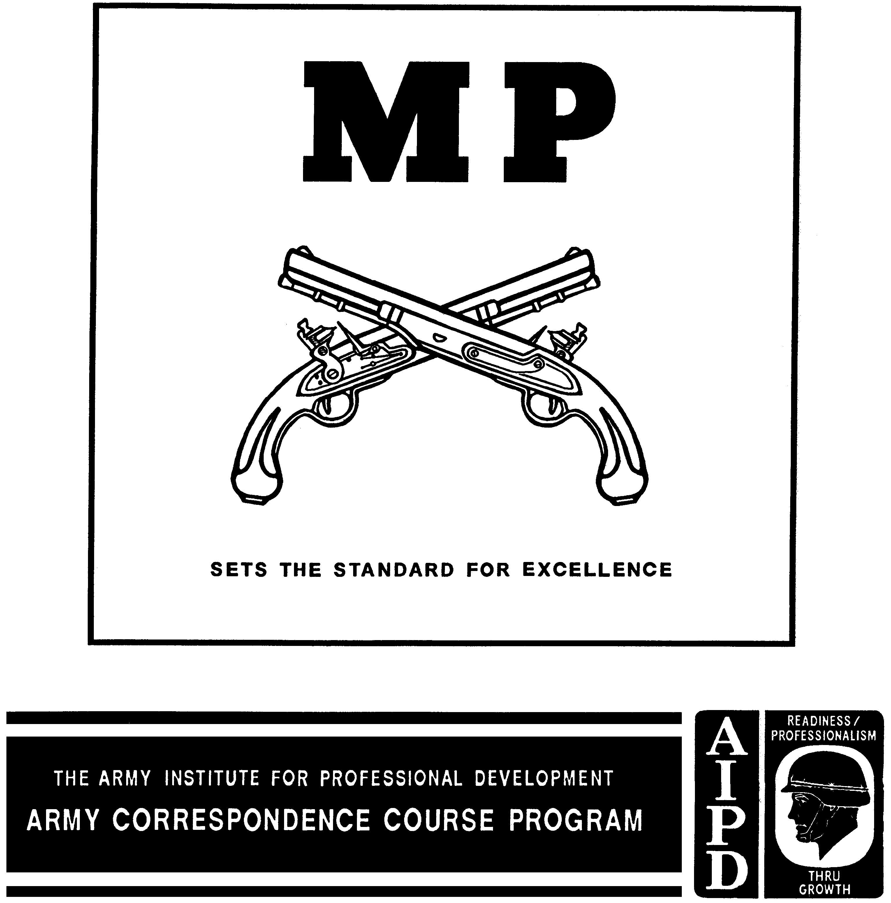

ENEMY PRISONER OF WAR (EPW) AND
CIVILIAN INTERNEE (CI) OPERATIONS

Subcourse Number MP 1032

EDITION C

4 Credit Hours

Edition Date: December 1996

SUBCOURSE OVERVIEW

As a military police supervisor, you may become involved with EPW/CI operations in a variety of ways. The Army Military Police have the primary responsibility for EPW/CI operations for the Department of Defense. In any form of hostilities in which the United States is involved, persons that are captured or surrender who cannot be readily classified will be treated as EPW/CI until such time as they are reclassified by competent authority. This includes low intensity conflicts, as well as declared wars. In some cases, you may find yourself as an advisor to other countries. You will be expected to encourage those whom you are advising to afford the same treatment to their prisoners.

The MP enemy prisoner of war mission is of humane as well as tactical importance. In any conflict involving U.S. forces, safe and humane treatment of EPWs is provided. MP perform their EPW operations in order to collect and evacuate EPW/CI from the main battle area. Remnants of entire units of enemy forces, separated and disorganized from the shock of combat, may be captured.

This will place a tremendous burden on tactical forces. Tactical commanders must have their forces available for combat. At the same time, they must resolve the problem of removing EPW/CI from the main battle area.

Tactical commanders at all levels will look to the military police to relieve them of this problem. Military police support tactical commanders by undertaking the type EPW/CI operations outlined in this subcourse. The primary mission of the MP when performing this task in the main battle area is to relieve the tactical commander as quickly as possible of EPW. The purpose is to prevent his having to devote vital combat resources to this mission.

Military police receive EPW/CI from combat units as far forward as possible. They maintain accountability of them. Protection and humane treatment are afforded them. EPW/CI are safeguarded and evacuated to the rear promptly. Those MP units involved in combat in the rear area as response forces also

i MP1032

function as capturing troops. This may also be true in low intensity conflicts.

In a mature theater of operations, MP escort guard companies, guard companies, and prisoner of war processing squads, guard and process EPW/CI collected by MP units in the combat area. MP units also guard EPW/CI in the communications zone, allied countries, or in the continental United States. Throughout this subcourse, the "H" series Table of Organization (TOE) has been used. The Army is currently converting to the "L" series TOE. Where this affects doctrine and procedures, it has been indicated. A discussion of the "L" series units has been included near the beginning of Lesson 3.

Basic U.S. policy underlying the treatment accorded EPW and all other enemy personnel captured, interned, or otherwise held in U.S. Army custody during the course of a conflict requires and directs that all such personnel be accorded humanitarian care and treatment from the moment of custody until final release or repatriation. The observance of this policy is fully and equally binding upon U.S. personnel, whether capturing troops, custodial personnel, or in whatever other capacity they may be serving. This policy is equally applicable for the protection of all detained or interned personnel, whether their status is that of prisoner of war, civilian internee, or any other category. It is applicable whether they are known to have, or are suspected of having, committed serious offenses which could be characterized as a war crime. The punishment of such persons is administered by due process of law and under the legally constituted authority. The administration of inhumane treatment, even if committed under stress of combat and with deep provocation, is a serious and punishable violation under national law, international law, and the Uniform Code of Military Justice.

Violations of this policy, and the laws and regulations may result in an individual being prosecuted as a war criminal. Anyone observing a violation of law, or suspecting one has happened, has a positive legal obligation to report it to appropriate authorities. Failure to do so is a violation in itself.

Throughout this subcourse, EPW and CI will often be referred together. The reason for this is that much of the handling of these two categories is the same and this treatment avoids repetition. The student must, however, realize that these are two separate and distinct categories. Only in unusual circumstances will the two be mixed together.

We designed this subcourse to teach you the basic procedures in handling EPW/CIs. Contained within the subcourse is instruction on how to perform the EPW/CI mission consisting of planning, processing, movement, security, and control activities.

There are no prerequisites for this subcourse.

This subcourse reflects the doctrine which was current at the time it was prepared. In your own work situation, always refer to the latest official publication.

MP1032 ii

Unless otherwise stated, the masculine gender of singular pronouns is used to refer to both men and women.

TERMINAL LEARNING OBJECTIVE

ACTION: You will identify the procedures for planning, processing, movement, security and control of EPW/CIs.

CONDITION: You will have access to this subcourse.

STANDARD: To demonstrate competency of this task, you must achieve a minimum score of 70 percent on the subcourse examination.

iii MP1032

TABLE OF CONTENTS
Section Page

Subcourse Overview i

Administrative Instructions v

Grading and Certification Instructions v

LESSON 1: Prepare a Processing Plan for EPW/CI 1-1

Part A: EPW/CI Operations and Responsibilities 1-3

Part B: Classification and Handling EPW/CI 1-6

Part C: MP Actions 1-12

Part D: EPW/CI Collective and Holding Areas 1-16

Practice Exercise 1-24

Answer Key and Feedback 1-26

LESSON 2: Plan and Direct Movement of EPW/CI 2-1

Practice Exercise 2-14

Answer Key and Feedback 2-16

LESSON 3: Supervise the Processing of EPW/CI at an EPW Facility 3-1

Part A: Organizations 3-2

Part B: Reception Facility Operations 3-7

Part C: Internment Facilities 3-13

Part D: Security and Discipline 3-23

Part E: Civilian Internees 3-26

Practice Exercise 3-30

Answer Key and Feedback 3-32

Examination E-1

Student Inquiries

MP1032 iv
GRADING AND CERTIFICATION INSTRUCTIONS

Examination: This subcourse contains a multiple-choice examination covering the material in the three lessons. After studying the lessons and working through the practice exercises, complete the examination. Mark your answers in the subcourse booklet, then transfer them to the ACCP examination response sheet. Completely black out the lettered oval which corresponds to your selection (A, B, C, or D). Use a number 2 lead pencil to mark your responses. When you complete the ACCP examination response sheet, mail it in the preaddressed envelope you received with this subcourse. You will receive an examination score in the mail. You will receive four credit hours for successful completion of this examination.

v MP1032

LESSON 1

PREPARE A PROCESSING PLAN FOR EPW/CI

Critical Task: 191-379-4406

OVERVIEW

LESSON DESCRIPTION:

In this lesson you will learn to prepare a processing plan for EPW/CI.

TERMINAL LEARNING OBJECTIVE:

ACTION: Prepare a processing plan for EPW/CI.

CONDITIONS: You will have this subcourse, pencil and paper.

STANDARD: Evaluation of your performance will be by successful completion of the examination (70 percent).

REFERENCES: The material contained in this lesson was derived from the following publications: AR 37-36, AR 190-8, AR 190-22, AR 190-57, FM 19-1, FM 19-4, and FM 19-40.

INTRODUCTION

1. General.

Future battles will be intense, fast moving, and deadly. They will stress air and ground operations across the entire battlefield. Combat will not cease for darkness or bad weather. The battle will be one of constant movement. Air mobility and long-range weapons will make traditional battle lines obsolete. Units will fight on a battlefield that extends from friendly rear areas to the enemy's territory. Combat action can be anticipated throughout the theater, including the communications zone.

a. The modern battlefield will be filled with a dynamic flow of offensive and defensive operations; it will be characterized by highly intense periods of conflict. Units will become isolated. They may also be attacked by nuclear and chemical weapons. Entire units, or major remnants of them, may surrender. The U.S. tactical commander needs all of his combat forces. A mission of the military police will be to relieve the capturing troops of EPW/CI as rapidly as possible.

1-1 MP1032

It must also be realized that warfare since the end of World War II has been primarily Operations Other Than War (OOTW). It has been limited warfare. Military police must be prepared to handle captured personnel in these circumstances as well. These conflicts are often characterized by enemy actions that are not always in keeping with the traditional laws of land warfare. Lines between military and criminal activity may become blurred. Regardless, all U.S. troops, and especially military police, must remember to abide by the rules of land warfare. As a military police supervisor, you will often be responsible for handling captured personnel.

b. The Geneva and Hague Conventions apply whenever the United States is a party to a conflict, whether or not a formal state of war exists. The MP EPW/CI mission is of humane as well as tactical importance. In any conflict involving U.S. forces, safe and humane treatment of EPW is provided. MP conduct collection and evacuation operations and internment operations to support their EPW mission. Most MP on the battlefield collect and evacuate EPW from the battle area. MP ease and control the flow of EPW from the time of capture until they are interned, transferred to host nation or allied forces, or repatriated at EPW facilities. However, the United States is responsible for ensuring the humane treatment of those EPW transferred to the custody of other nations. Those MP assigned to the functional MP units dealing with EPW perform internment operations. Other MP in the rear areas may find themselves as capturing troops as well.

c. EPW/CI have had to be handled in all modern conflicts. The mission of the military police is to relieve the combat forces of this responsibility as rapidly as possible. Massive numbers of prisoners have been taken by both sides in the Iran-Iraq conflict. During British operations in the Falklands, 23 Royal Military Police were able to control 14,000 Argentine prisoners. In Grenada, 40 MP from the XVIII Airborne Corps were responsible for the processing and evacuation of Cuban prisoners. Military police in the Vietnam conflict were also involved in the handling of EPW/CI under special circumstances. MP also found themselves serving as advisors to the Vietnamese military police handling EPW/CI.

2. Four MP Missions.

a. Military police have four missions on the battlefield:

o Battlefield circulation control.

o Area security.

o EPW/CI operations.

o Law and order-operations.

b. The echelon commander establishes the priority of MP missions through the provost marshal. In almost all cases, MP will perform all four to some degree. Each of these missions is composed of a number of operations. The operations are done independently or in any combination. The importance and

MP1032 1-2

priority of these tasks at any given time will be determined by the commander. This priority can change very quickly. The primary concern is to meet the commander's need with whatever resources are available. This subcourse deals with the responsibilities in EPW/CI operations.

PART A - EPW/CI OPERATIONS AND RESPONSIBILITIES

1. EPW/CI Operations.

a. MP perform collection, evacuation, and internment operations to receive, safeguard, and intern EPW/CI. EPW/CI are received from capturing troops. Capturing troops may well be other MP. They may also be units of the U.S. Air Force (USAF) and the U.S. Navy (USN). All MP must be prepared to receive EPW/CI. This includes military police in rear areas performing missions having little to do with EPW operations.

b. Prisoners captured in the main battle area are normally brought to a division forward collecting point. These points are usually located in the brigade support area. They are operated by MP in direct support of brigades and MP assigned to separate brigades. MP do not establish "forward" collecting points in light infantry divisions. Sick and wounded EPW are placed in medical channels. MP operating the division central collecting point receive EPW/CI captured in the division rear area and prisoners evacuated from the forward collecting points. Normally, MP from the division general support (GS) platoon go forward to evacuate prisoners. In other words, they go to the forward collecting points and escort prisoners back to the central collecting point. Corps MP go forward to the division central collecting point and evacuate prisoners to the corps holding areas. Prisoners should be evacuated as rapidly as possible to free MP for other tasks.

c. Rapid evacuation also gets prisoners away from the main battle area to safety. This is a requirement of international law.

d. In rear areas, combat service support units, as well as MP, may also capture EPW/CI. These prisoners will be turned over to the nearest U.S. Army military police element, regardless of its primary mission. These MP elements will arrange for the evacuation of the EPW/CI with the appropriate MP unit as rapidly as possible.

e. As with the division, prisoners are held at the corps holding area for the minimum amount of time. MP from the communications zone will go forward to the corps and evacuate the prisoners to facilities in the communications zone.

f. EPW/CI internment is the confining or enclosing of EPW/CI in facilities located in the communications zone (COMMZ)-or continental U.S. U.S. MP have not conducted internment operations since the Korean conflict. However, during the Vietnam conflict, some of the EPW collecting points were required to hold prisoners for extended periods of time due to the nature of the operations.

1-3 MP1032

g. In the COMMZ, main facilities are usually located in the rear, near railways, airports, medical facilities, and transportation centers. One or more facilities may be located forward in the COMMZ. This is a facility designated to receive and conduct the initial processing of EPW. How many reception facilities there are, and their location, depends on the force to be supported. It also will depend on factors such as transportation and the depth of the theater. Where appropriate, host nation agreements must also be considered. This is applicable in Europe and sometimes in low intensity conflicts, such as Vietnam. The MP prisoner of war brigade or prisoner of war command (when assigned) is responsible for internment operations in the COMMZ. A prisoner of war command is assigned when the EPW mission exceeds the capability of the prisoner of war brigade. The prisoner of war brigade is assigned to the PERSCOM. In theaters where a PERSCOM does not exist, the prisoner of war brigade is assigned to the theater Army MP brigade. When a prisoner of war command is assigned it assumes responsibility for prisoner of war operations, and replaces the PERSCOM for command and control of assigned EPW units.

2. Responsibilities.

a. Commander.

(1) The commander is responsible for all that his unit does or fails to do. In the area of EPW/CI operations, he is responsible to ensure that U.S. policy is carried out. U.S. policy pertaining to EPW/CI is listed in the introduction to this subcourse. In general, the commander must provide for:

o The implementation of the Geneva Conventions and other treaties or agreements.

o Humane and efficient care, and full accountability for all persons captured or detained.

These responsibilities are implemented through the various staff officers and subordinate commanders.

Commanders at all levels are responsible for ensuring that their personnel are familiar with the law of land warfare, and that they abide by it. The provisions of the Geneva Conventions are applicable to the handling of prisoners from the time they are captured until they are released or repatriated. When a person is captured, even in the heat of battle, he must be given the protection to which he is entitled as an EPW/CI. When the U.S. ratifies treaties, such as the Geneva Conventions, they become U.S. law.

Under all circumstances, prisoners are to receive humane treatment without distinction based on race, nationality, religious belief, political opinion, or other similar criteria. EPW/CI may not be murdered, mutilated, tortured, or degraded. They may not be punished without a previous judgment pronounced by a legally constituted court. They are entitled to those judicial guarantees which are recognized as indispensable to a fair trial.

MP1032 1-4

(2) All EPW/CI are entitled to respect for their persons and honor as human beings. They are to be protected against acts of violence, insults, public curiosity, and reprisals. They are required to give name, age, and service number, however, no form of coercion may be inflicted on them to obtain any information. Those who refuse to answer may not be threatened, insulted, or exposed to unpleasant treatment of any kind.

(3) Female prisoners are to receive treatment at least as favorable as that accorded to males. They are to be treated with all regard due their sex.

b. Provost Marshal (PM).

The PM at each level of command is responsible for coordinating with the S1/G1/J1 for the development of the plans, policies, and procedures pertaining to EPW/CI. The PM at each level of command is responsible for the development of plans, policies, and procedures pertaining to EPW/CI. He accomplishes this in close coordination with other staff agencies. Sites for the location of EPW/CI facilities are recommended by the PM. In the COMMZ, this is done by the PW brigade commander.

The need for and the plans to use MP assets to conduct EPW/CI operations are determined by the PM. He considers the number and capture rate of prisoners. The MP company commander is tasked to set and operate collecting points or holding areas. This will include providing guards and processing prisoners.

In a division, the PM operations section does the initial planning for evacuating prisoners. The PM tasks the company commander to execute the plans. In a corps, the MP brigade S3 tasks battalion commanders to execute the plan. The battalion, in turn, passes the requirement to one or more of its companies. In the COMMZ, the PW brigade operations staff tasks subordinate elements to accomplish the appropriate tasks.

c. ACofS, G1.

The G1 has primary coordinating staff responsibility for EPW/CI activities in the command. He ensures that the interests of other staff officers are considered in the development and execution of EPW/CI plans. The G1 is responsible for writing the EPW/CI plan. In addition to overall responsibility, the G1 also has primary staff responsibility for medical support.

d. ACofS, G2.

The intelligence staff officer is responsible for providing, the estimated capture rate of EPW/CI, upon which plans are based. He also has the staff responsibility for the interrogation of EPW/CI to gain intelligence information. The G2 will also establish a mail censorship program, when appropriate. Classification of EPW/CI is also a G2 responsibility.

1-5 MP1032

e. ACofS, G3.

The organization, training, and employment of military police units is the responsibility of the G3. The G3 uses his knowledge of overall operations to estimate the number of military police that will be required to conduct the EPW/CI mission. He does this in coordination with the PM, G1, and G2. The location of EPW/CI facilities is also his responsibility. This is based on a recommendation from the PM. The training of MP to execute their mission is the G3's responsibility.

f. ACofS, G4.

The G4 is the staff officer responsible for the provision of food, clothing, transportation, and shelter for EPW. He also collects and disposes of captured enemy supplies and equipment. The acquisition of real estate and construction of facilities are accomplished under his staff supervision. In selected cases, the G4 will plan for the use of prisoners for logistical support operations.

g. ACofS, G5.

The G5 is responsible for the coordination of activities relating to relationships between EPW facilities and the local population. He also provides technical advice and assistance about labor policy for the support of the local population.

h. Chaplain.

The chaplain has the staff responsibility of coordinating religious activities of the EPW/CI.

i. Staff Judge Advocate (SJA).

The SJA provides legal advice and support. His support is particularly important in interpreting the law of land warfare. He also provides a great deal of advice and assistance in the interpretation and applicability of law during internment. The SJA and CID are responsible for the investigation of war crimes.

j. Inspector General (IG).

Receipt of allegations of war crimes is an IG responsibility. This includes allegations made by both prisoners and U.S. forces personnel. Responsibility for the investigation of war crimes rests with the SJA and CID.

PART B CLASSIFICATION AND HANDLING EPW/CI

1. Classification of Captured Personnel.

A major responsibility of the G2 is the classification of captured personnel. The treatment afforded them depends in large measure upon their status. All

MP1032 1-6

captured personnel are treated as EPW until determined otherwise. Procedures will have been established for the reclassification of captured personnel before they are assigned an interment serial number (ISN). This is accomplished at the PW facility.

Captured personnel are placed into one of three broad categories. These are EPW, CI, and Retained Persons (RP). Innocent civilians are released immediately.

a. Innocent Civilian. These are individuals who have been accidentally caught up in the combat environment. This category would include refugees that have been inadvertently taken prisoner by combat units. Innocent civilians should be released from custody as quickly as possible. Transport to the point of capture or to their home is required if at all possible. The assistance of the G5 for refugee handling may be required. Innocent civilians can become a major category in counter-insurgency warfare.

b. Categories of Captured Personnel. The following chart (see Figure 1-1) provides the factors which qualify a person to be placed in a category. Remember all personnel are treated as EPW until their status is determined to be otherwise.

2. Principles in Handling EPW/CI.

Certain principles must be adhered to for the U.S. to comply with its international obligations. Additionally, the treatment we afford EPW/CI may affect the manner in which the enemy treats our prisoners. These principles include:

o Humane treatment.

o Prompt evacuation from the combat zone.

o Provisions for the interrogation of EPW.

o Instruction of all troops in the provisions of international agreements and regulations relating to EPW/CI.

o Integration of procedures for the evacuation, control, and administration of EPW/CI with other combat support and combat service support operations.

3. Objectives of Handling EPW/CI.

The objectives to be met in handling EPW/CI will be discussed below. There are many reasons for handling prisoners in a humane but firm and safe manner. The first, of course, is that it is the law. But beyond the requirements of law, there are logical reasons for the manner in which prisoners are handled.

1-7 MP1032

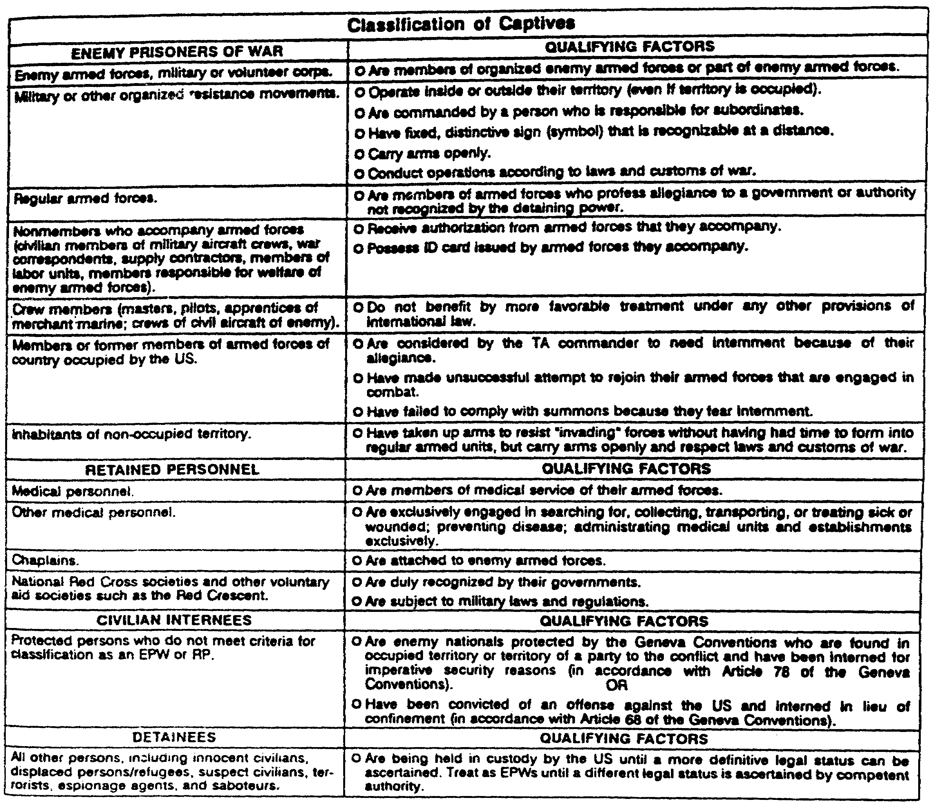

Figure 1-1. Classification of Captives.

a. Maximize Intelligence Information. Proper treatment, particularly immediately after the shock of battle, inclines prisoners to provide information. History has repeatedly shown that improper treatment only causes greater resistance, or just as bad from an intelligence point of view, causes prisoners to tell their captors what they think they want to hear. The information thus gained has little value. The conventions prohibit acts of coercion; they do not prohibit asking questions. In addition to information that the EPW may reveal verbally, his uniform, equipment, and-papers he is carrying may reveal a great deal about the enemy.

b. Prevent Escape or Liberation. Every enemy soldier captured is one less soldier that our combat forces have to fight. Escapees can also provide a great deal of intelligence information to the enemy forces if their escape

MP1032 1-8

or liberation is successful. When prisoners are properly treated, they are less inclined to attempt to escape. It also aids in gaining their cooperation in daily routine, rather than active or passive resistance. Remember that just as it is your duty to attempt to escape when captured, the enemy soldier has the same duty. Your task is to prevent him from succeeding.

c. Promote Proper Treatment of Captured U.S. Personnel. Whether we like it or not, U.S. personnel will be captured by the enemy. If we treat enemy prisoners properly, there is a greater likelihood that they will treat our personnel in the same manner. In any case, improper treatment would certainly invite reprisals against them.

d. Weaken the Will of the Enemy to Resist. Fear of mistreatment is a deterrent to surrender. Atrocities embitter and strengthen the will of the enemy to resist. Decent treatment of prisoners encourages others to surrender. There were particularly strong examples of this during both the Korean and Vietnam conflicts.

e. Use EPW/CI as a Source of Labor. Enlisted prisoners may be used to work on many projects in the rear area. Their NCOs may be used to supervise them. Officers may volunteer to participate. There are restrictions on their employment, but their use frees our people for other jobs.

4. Prisoner Obligations.

An EPW/CI has two primary obligations. He is obliged to give his name, rank, serial number, and date of birth. This is all the information he is obliged to give. He may be questioned about other matters, but is not required to answer. No form of coercion may be used to force him to reveal any information. Secondly, he is obliged to obey the rules of the camp in which he is interned. EPW are subject to both their own military regulations and to the rules of the nation that captured them. If they violate such rules, they may be punished only after a fair and impartial trial.

5. Rights of EPW/CI.

All EPW have certain rights that are guaranteed them. As the capturing power, it is our responsibility to ensure these rights are not violated. All EPW/CI are accorded humane treatment. They are to be protected against acts of violence or intimidation, insults, or public curiosity. Medical care must be provided. Wounded, sick, and injured prisoners are evacuated through medical channels and are given the same medical treatment as U.S. personnel. Retained medical personnel may be used to treat EPW. All property taken from prisoners will be accounted for. It must be disposed of in accordance with the laws of war and U.S. regulations. Personal property of the prisoners, in particular, will be respected. All prisoners will be provided-adequate food, shelter, and clothing. When possible, particular dietary habits of the prisoners will be respected. For example, Moslem or Jewish prisoners would not be fed pork if reasonably possible. Care and food will be at least equivalent to that afforded U.S. troops. EPW/CI are permitted mail privileges. There is no restriction on the number of letters or cards EPW may receive. If it is

1-9 MP1032

necessary to limit the number of cards and letters each detainee sends, the number will nor be less than 2 letters and 4 cards monthly. These letters and cards will be written on DA Forms 2667-R and 2668-R respectively.

6. Capturing Troops Procedures.

a. Capturing troops are those troops that take initial custody of an enemy soldier when he surrenders. They may be combat forces. They may be military police operating in a combat role. Members of the USAF and USN may also be capturing troops. Army combat service support troops may also capture enemy soldiers in the rear area. The procedures to be followed by all of them are the same.

b. It is the responsibility of the unit commander of U.S. Forces to ensure that their personnel are familiar with the Law of Land Warfare. It is also their responsibility to train their personnel in the proper actions to take when capturing enemy personnel. Upon initial capture, all persons are treated as EPW.

7. Search and Disarm.

a. The prisoner must first be disarmed and searched. This search is to locate concealed weapons. Capturing troops should also seek equipment and documents that may be of intelligence value. Until each EPW is searched, capturing troops must be particularly alert to prevent the use of concealed weapons, or the destruction of documents or equipment.

b. Prisoners should be permitted to retain all of their personal effects. They should also be permitted to retain items of defensive military equipment that are of no intelligence value (e.g., protective masks). When items of personal protection are seized, equivalent replacement items should be issued. For example, a helmet or protective mask with writing, diagrams, or unusual insignia might be seized. These must then be replaced until the original items are returned. Personal items include money and other valuables. Prisoners should retain their identification cards and tags, badges of rank and nationality, and articles having a sentimental or personal value. Although EPW should be permitted to retain eating utensils, the knives and forks should be removed. Care must be taken when items are seized that they can later be identified with the prisoner from whom they were taken. This is critical to the intelligence personnel. Additionally, some of the items may have to be returned to the prisoner at a later date.

c. A receipt will be given to the EPW from whom personal property or documents are taken. A copy of this receipt is given to the person in charge of the escort detail. He will turn the receipt over to the MP at the collecting point. The receipt will include:

o Name, rank, and serial number of the EPW.

o A brief description of the item taken.

MP1032 1-10

o Name, rank, SSN, and unit of the person that took it.

8. Segregate.

Segregation of EPW aids in the ease of their control. EPW should be segregated as quickly as possible. Segregation by categories first requires that individuals be identified. Time, and language barriers, do not normally permit a detailed interrogation at the point of capture. However, it may be possible to make at least a preliminary determination. For example, insignia and other indicators may allow the separation of officers from enlisted personnel. Males can be separated from females. When possible, EPW should be separated into the following categories:

o Officers.

o Noncommissioned officers.

o Other enlisted personnel.

o Sex.

o Deserters.

o Civilians.

o Nationality/ideology.

Segregation will facilitate the control of the prisoners. It also assists intelligence personnel during field interrogations. The above list represents an objective; it will often be difficult to meet all the categories.

9. Five S's and T.

a. A good method to remember the required actions by capturing troops is the five S's and T. They are:

Search. For weapons, military documents, or equipment, in the vicinity of capture, and tag with part C of the capture tag.

Segregate. By rank, nationality, sex.

Speed. Evacuate from point of capture quickly.

Silence. Prohibit talking among EPW, for ease of control.

Safeguard. To prevent harm or escape.

Tag. To provide information.

1-11 MP1032

b. Capture Tags.

The circumstances under which an individual is captured is important information. It will often be the most valid basis for determining status. Only the capturing troops have such knowledge. It is also critical intelligence information. This is particularly true of those EPW placed in medical channels or transported by helicopter, since they may end up far from the point of capture. It is important that the capturing troops complete a capture tag.

The capture tag should include the following, as a minimum:

o Date and time of capture.

o Place of capture (grid coordinates).

o Capturing unit.

o Circumstances of capture (How was he captured?).

c. Capturing troops are also required to tag equipment, documents, and other items taken from the EPW. This helps link the items with the prisoner at a later date. Standard capture tags (see Figure 1-2) specified in Standardization Agreement (STANAG) 2044 are used by U.S. forces in NATO. The tag should be perforated in three parts. It should be of a durable material. Part A of the NATO standard capture tag is attached to the prisoner. Part C is attached to items taken from the prisoner. Part B, when used, is retained by the capturing unit according to local standing operating procedures (SOP). STANAG 2044 requires use of Part A and Part C of the standard capture tag. Using Part B is optional. When "issue" tags are not available, troops should obtain or manufacture their own field expedient. The most important thing is to convey the information.

PART C - MP ACTIONS

1. General.

Soldiers from the capturing unit bring EPW to the nearest military police unit. Military police accept custody for EPW anywhere from the point of capture rearward. Normally this will be at the forward collecting point. MP count the EPW and accept custody of them. They also take control of confiscated documents and equipment.

To control EPW, MP perform specific procedures for field processing prisoners at a collecting point, or elsewhere. They search, tag, report, evacuate, segregate, and safeguard the prisoners. The key word STRESS is a good memory device for these procedures.

MP1032 1-12

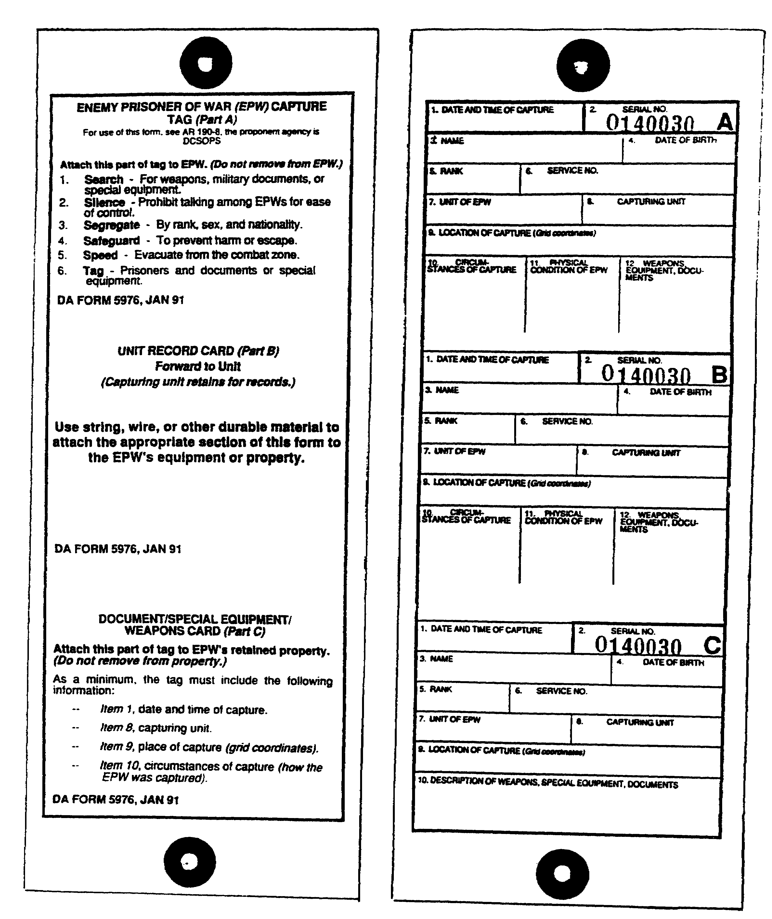

Figure 1-2. Capture Tag.

1-13 MP1032

2. Search. Even though the capturing troops have already searched the prisoners, they should be searched again. This will be a more detailed search than that normally done by the capturing troops. The search is for concealed weapons, as well as for items of intelligence value. Prisoners are allowed to keep personal items of no military value. Any protective gear that is taken, such as helmets or protective masks, must be replaced.

3. Tags. MP check the tag on each prisoner. They must make sure that the essential information is filled in. If a prisoner is not wearing a tag, MP place a tag on him. The tag is filled out as accurately as possible. Information may be obtained from the guards escorting him. MP that have to complete a tag this way state on the tag that the prisoner arrived at the collection point without a tag.

4. Report. The MP in charge makes an EPW status report through his chain of command. The format and frequency of this report are specified in unit SOP. Figure 1-3 is a sample of such a report. Accurate reports are a must for planning transportation and guard requirements. The reports also serve as a valuable historical record. They show how many prisoners were received and where they were sent. There is a legal requirement that all EPW/CI be accounted for. Just as we want an accounting of those of our people that have fallen into enemy hands, the reverse is also true. As previously noted, the manner in which we treat, and account for, EPW can affect how the enemy treats our people.

5. Evacuate. EPW should be evacuated from the collecting points as soon as possible. The squad leader coordinates with his platoon leader for their removal. The platoon leader requests guards and transportation from the company commander. The company commander obtains support through the PM operations section. Non-divisional military police that have received custody of EPW should contact the nearest MP unit handling EPW, through their chain of command.

6. Segregation. Segregation of EPW is crucial to maintaining control and security. Enemy officers or NCOs may try to influence other prisoners to resist or try to escape. If the capturing troops did not segregate the prisoners, MP should do it. If some segregation has been accomplished, MP may be able to further segregate them. Segregation at the collecting point is done using field expedient material. At forward collecting points, this may be no more than marking different areas with engineer tape. Concertina wire may also be used. The prisoners are segregated so that categories cannot communicate, either by voice or visually. MP at this stage follow the same categories of segregation as the capturing troops.

MP1032 1-14

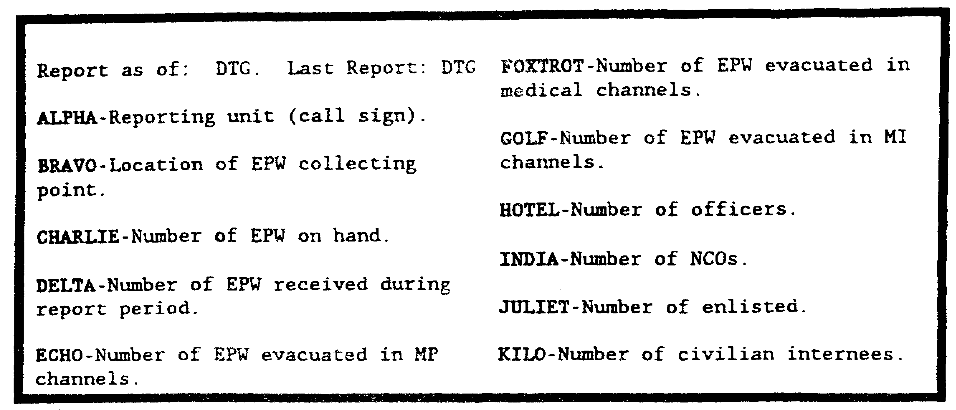

Figure 1-3. Enemy Prisoner of War Report.

7. Safeguard. MP protect EPW from harm and prevent their escape. Prisoners must be guarded, given medical care, and provided basic sanitation. MP are not required to provide NBC protective equipment to EPW that arrive at the collecting point without it. If an NBC environment is expected or encountered, every effort should be made to leave or avoid the contaminated area. If extra equipment is on hand, MP use it to protect the prisoners as best they can. When available, maximum use of captured enemy equipment, of no intelligence value, should be made.

MP communicate with the prisoners only to give commands and instructions. An interrogating team may be located near each collecting point. They are responsible for interrogating prisoners. Members of this team are the only persons allowed to interrogate EPW without special permission. The interrogation should be conducted near the collecting point. A guard may be provided by MP if assets are available. Evacuation from the collecting point is not normally delayed for interrogations.

8. EPW/CI Property.

Property of EPW/CI are classified into three types. Retained property is that which the prisoner is permitted to keep. Examples of this type property are health and comfort items, rank and national insignia, religious medals, personal jewelry, and photographs. It also includes such military items as protective masks, helmets, and eating utensils (less knives and forks). Impounded property consists of items taken from the prisoner that will later be returned to him, usually upon his release. This would include such items as cameras and radios. Any item in this-category that is seized must be receipted for. A copy is provided the prisoner. Normally, DA Form 4137 will be used for this purpose. The final category is confiscated property. This is property that has been seized without any intention of its return. Normally, it will consist of military items. Examples include weapons, maps,

1-15 MP1032

communications equipment and documents. MP use DA Form 3161 (Request for Issue or Turn-In) to account for items that will be turned in to supply channels.

PART D - EPW/CI COLLECTING/HOLDING AREAS

1. Forward Collecting Point.

A division forward collecting point (DFCP) (see Figure 1-4) is established in or near the brigade support area. It is operated by MP in direct support of the brigade and MP assigned to separate brigades. The platoon leader selects the precise location. He coordinates with the commander responsible for the area to make sure it will not interfere with other operations.

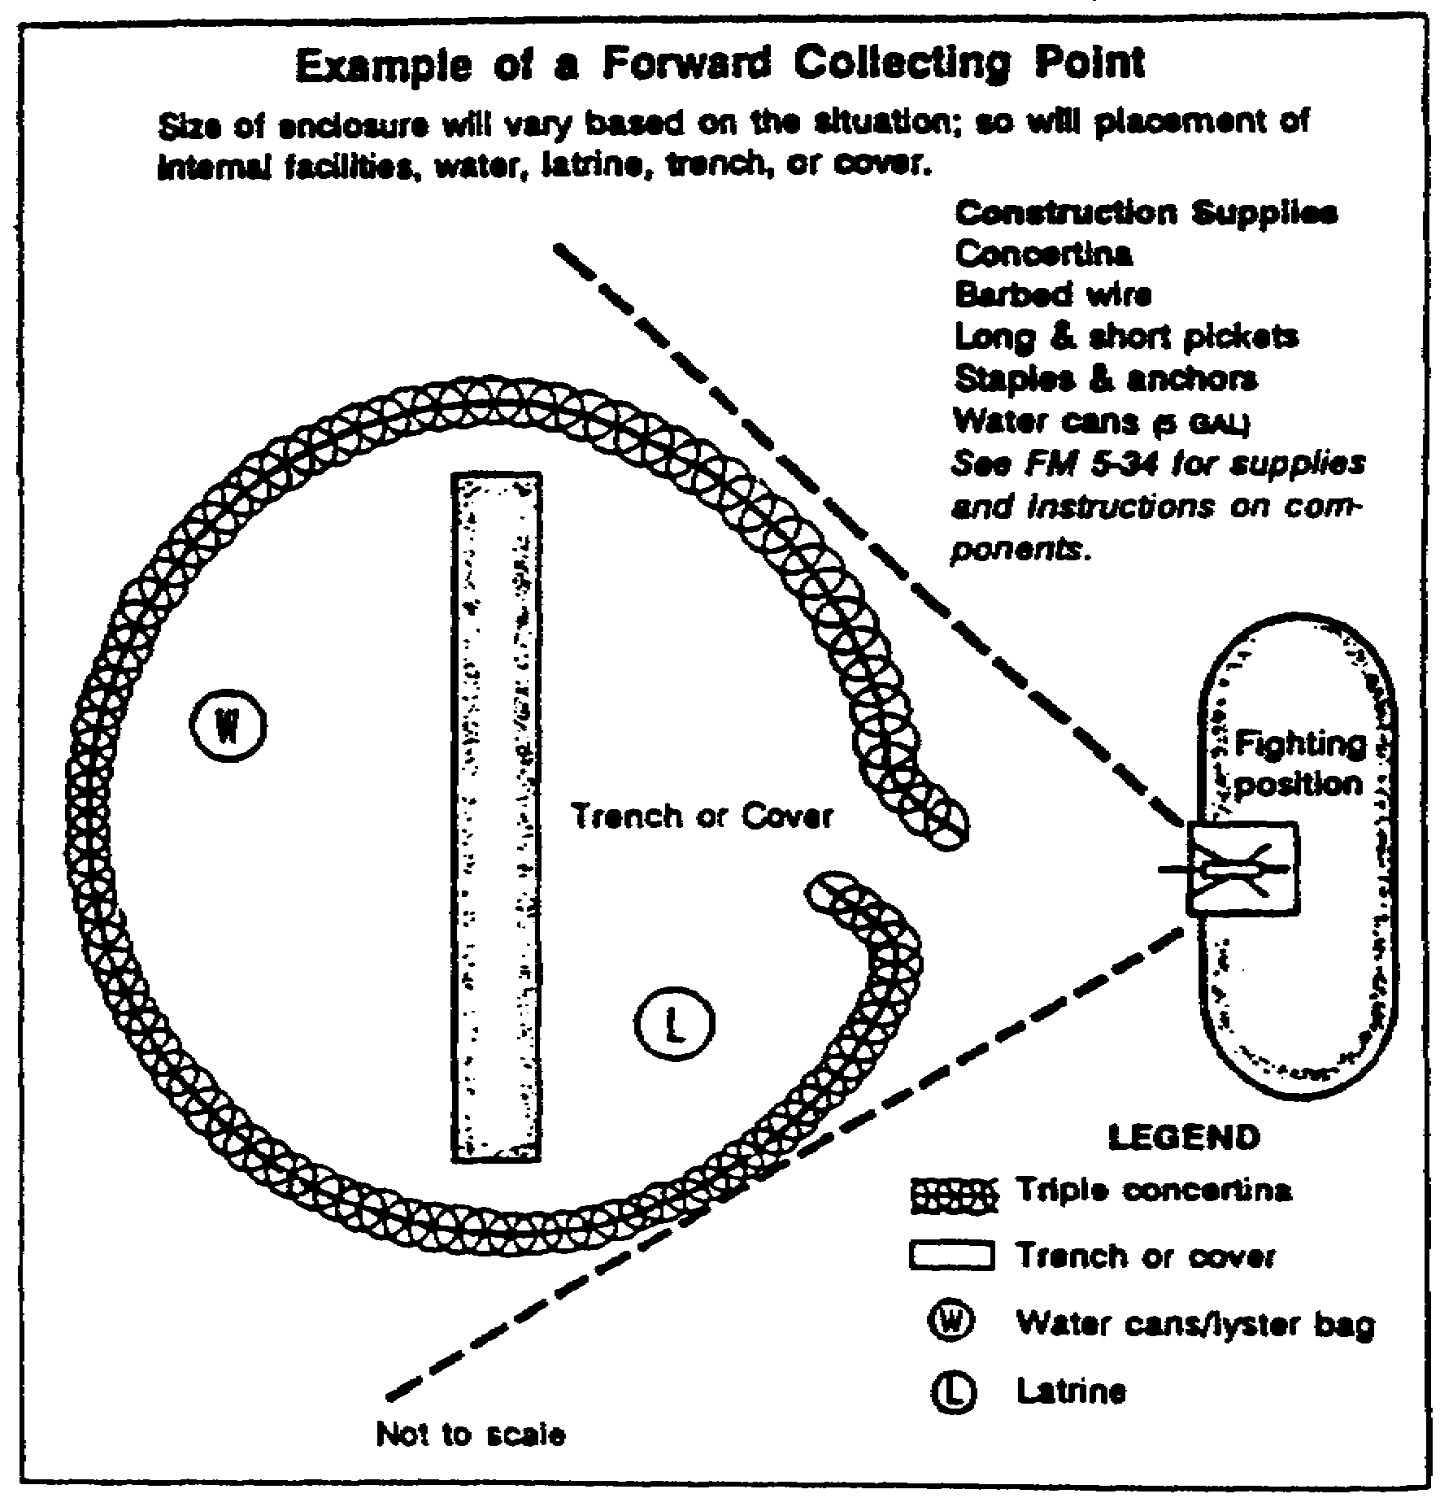

Figure 1-4. Forward Collecting Point.

a. Site Selection.

The site selection is based on the factors of METT-T. It must be remembered that the DFCP is usually temporary. The location must be one where the guards can easily watch all of the prisoners with the minimum number of guards. At the same time, the site must provide sufficient space for segregation.

MP1032 1-16

The location should be far enough in the rear to avoid minor fluctuations in the battle front. At the same time, it must be far enough forward to allow combat units to dispose of EPW quickly. The site should be one that provides maximum cover for the prisoners, without endangering security. Consideration should also be given to locating the site near the main supply route (MSR) to facilitate transportation. The collecting point must be located out of sight of friendly military operations. This prevents the prisoners from gathering intelligence information should they escape.

b. Operations.

The DFCP is a temporary facility. It is operated only on an as needed basis. When established, it must be capable of being moved quickly. Concertina wire is usually used to mark off the collecting point. Provisions for segregating prisoners should be made, when possible. If the brigade is in a defensive position, and/or anticipates staying in place for an extended period of time, constant improvements are made to the facility.

(1) The number of MP needed to operate a DFCP will vary with METT-T. A squad is usually tasked to operate the DFCP.

One MP team is tasked to receive and release prisoners. The remaining two teams are used to safeguard the prisoners on alternating shifts.

(2) The squad ensures that water and food are provided. They should have extra prisoner of war tags available. Arrangements should also be made for the medical treatment of prisoners.

(3) EPW are normally evacuated from the DFCP to the division central collecting point (DCCP) as rapidly as possible. This is accomplished by MP from the general support (GS) platoons of the division MP company. Corps MP evacuate EPW from the DCCP. EPW are evacuated from corps holding areas (CHA) by Theater Army MP. When possible, MP from an escort guard company are used. MP from a Theater Army Area Command (TAACOM) MP Brigade may be tasked to evacuate EPW from CHA when the ability of escort guard MPs is exceeded.

c. Functions.

The DFCP accepts and secures EPW delivered by combat troops. This includes receipting for both the prisoners and property.

All prisoners are searched, safeguarded, and segregated. Shelter from the elements is provided, if available. EPW should be required to dig an adequate number of foxholes for their personal protection. Medical supplies are provided to allow EPW to treat minor wounds. If possible, nonwalking wounded or sick prisoners are sent to the designated medical unit.

2. Division Central Collecting Point.

The DCCP is located near the division support command. It is operated by MP from one of the GS platoons of the division MP company. The platoon leader

1-17 MP1032

selects the exact site, based on guidance from the company commander. Coordination is effected through the PM operations section to ensure it does not interfere with other operations. A central collecting point is larger than a forward collecting point. Your considerations for setting up and operating the collecting points are the same. But it can take many more MP elements to run a central collecting point. Augmentation by the division band and/or by corps MP elements augmenting division MP may be needed. When a division, corps, or echelons-above-corps band augments MP for EPW collection operations, they help MP prevent the escape or liberation of captives. The band members provide security. They control access to collecting points or holding areas. But band members do not process or interrogate captives.

a. Site Selection.

The site selected is located near an MSR and out of sight of friendly activities. Preferably, it is one that has existing facilities that can be adapted to handling prisoners. If possible, it should be near an aircraft landing area. There should be ready access to medical facilities. Operations are also eased if the site is near a reliable source of water.

b. Operations.

(1) The DCCP is normally operated by a squad. This may vary, depending on the capture rate and METT-T. The collecting point is operated similarly to that of the DFCP. It is larger and more permanent, however.

(a) The DCCP may be constructed of materials similar to those of the DFCP. In urban areas, a building or other structure is well-suited for this purpose. When an enclosed area of concertina wire or an existing facility is not available, the squad defines the limits, if only with engineer tape. It should contain tentage or other shelter. A bunker or similar facility should be provided for each subarea. At a minimum, prisoners must have free access to such a protective shelter in case of air or artillery attack. Figure 1-5 is an illustration of a DCCP.

(b) The DCCP should be capable of rapid displacement to meet changes in the tactical situation. Normally, prisoners should not remain at the division level longer than 24 hours.

(2) MI interrogating teams may be located near collecting points and holding areas in the combat zone. This allows for additional interrogation of prisoners brought from the forward collecting points, and initial interrogation of those prisoners brought directly to the central facility. Counterintelligence information may also be obtained.

MP1032 1-18

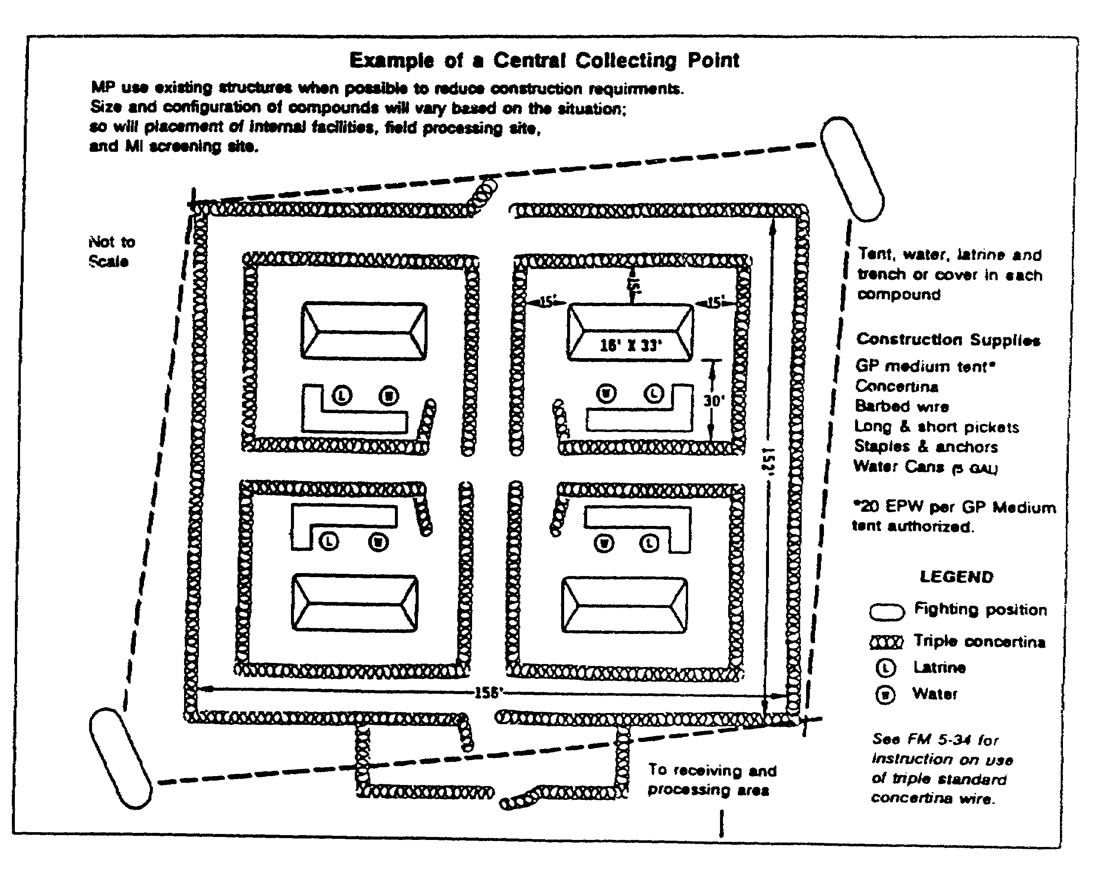

Figure 1-5. Central Collecting Point.

1-19 MP1032

(3) Escort guards are provided by corps; they may also be provided by the COMMZ through corps. They evacuate prisoners from the DCCP to a corps holding area or to the COMMZ.

c. Functions.

(1) Functions performed at the DCCP include:

o Providing security for, and safeguarding EPW/CI, and evacuation of prisoners from the forward collecting points. This includes providing receipts for both prisoners and property.

o Providing food, water, first aid and medical attention as required. Normally, the central collection point will be the location where the prisoners receive their first meal.

o Segregating prisoners.

o Coordinating the use of return transportation with the division transportation officer.

o Releasing of EPW/CI, and property, to guards for further evacuation.

(2) Equipment.

Equipment required for all division collecting points is listed below. This is not a complete list, and it excludes items normally used by the MP team. Precise requirements will be dictated by the situation. For example, while heaters may be required in a cold weather climate, they have little use in the tropics.

o Concertina wire, anchors, and stakes.

o Engineer tape.

o Communications equipment.

o Shelter. Maximum use of existing structures is recommended. Tents also may be used.

o Water containers, e.g., Lister bags.

o Lights and generator.

o Blankets.

o First aid supplies.

o Entrenching equipment.

MP1032 1-20

3. Corps Operations.

a. Evacuation Responsibilities.

The corps MP are responsible for the operation of the corps holding areas. They also provide escort guards to evacuate prisoners from the divisions. This includes both routine and, when tasked, medical channels. They arrange all transportation and provide rations and water for the movement, if needed.

b. Corps Holding Areas.

Corps MP may establish two types of holding areas. When distances or conditions do not allow movement of EPW/CI from the division within movement limits, a temporary facility may be established. It is located along the evacuation route. This is required when the move cannot be accomplished during daylight, or within an 8 to 10 hour period. Whenever possible, a suitable existing facility is used. It should provide shelter from the elements. Tents may be used. A wall, perimeter fence, or other barrier must be present, or be erected. Use of temporary CHA should be held to a minimum. The corps operates a CHA. This is a temporary construction, building, or enclosed area to which EPW are evacuated. It is not a permanent facility, but is used to hold EPW/CI until they can be evacuated to internment facilities.

Depending on the situation, it may be necessary to establish two or three holding areas. For economy of personnel, the minimum number of holding areas possible should be used. The holding area should be near the MSR or other transportation facilities, and should be located away from primary targets. Existing structures should be used where possible.

c. Operations.

Corps holding areas are operated on an austere basis. They should be designed to use the minimum number of MP possible. EPW are processed similarly to the way they are in the division.

Field processing at corps may include a further search of prisoners. Sanitary measures may include delousing of prisoners and disinfestation of their clothing, if required. New clothing may be issued. Bathing facilities should be made available if possible. Prisoners suspected of having communicable diseases or other medical problems should be examined by a doctor. Food and water are provided. Food preparation may be accomplished by the EPW/CI under supervision.

Intelligence interrogation is selective. Which EPW are to be interrogated depends on the evaluation of previously furnished information. The length of time devoted to any individual interrogation depends on the value and type of information being gained. Detailed interrogations may be conducted at this level.

1-21 MP1032

EPW/CI are evacuated from the CHA to the COMMZ with a minimum of delay. The corps MP coordinate transportation. They also provide rations if required for the movement. COMMZ MP evacuate EPW/CI from the CHA for internment.

MP1032 1-22

THIS PAGE LEFT BLANK INTENTIONALLY

1-23 MP1032

LESSON 1

PRACTICE EXERCISE

INTRODUCTION

This practice exercise will show you how much you have learned in this lesson. Select the correct answer to each question. When you are done, turn the page to check your answers.

1. Your squad has been assigned the mission of operating a division central collecting point. Some prisoners have been captured in the rear area. The capturing troops have brought them to your location. What does your mission require?

A. You redirect them to the forward collecting point closest to you.
B. You have your personnel accept the prisoners and follow the steps in STRESS.
C. All personal items are confiscated from the EPW.
D. All EPW are kept closely together so that it takes fewer guards.

2. In discussing the EPW planning process with your team leaders, one of them asks who is responsible for developing the division EPW plan. You tell him it is the

A. G1.
B. G2.
C. G3.
D. G4.
E. PM.

3. You are tasking your team leaders with their responsibilities. What tasks would be assigned each team?

A. One team safeguards; one team evacuates; one team guards.
B. One team accepts; one team guards; one team releases.
C. Two teams evacuate; one team guards.
D. One team receives and releases; two teams safeguard.

4. In searching the EPW a MP has found a military map. You know that this is what type of property?

A. Retained.
B. Contraband.
C. Confiscated.
D. Impounded.

MP1032 1-24

5. A group of four prisoners has been brought to your collecting point by capturing troops. Only three of them have capture tags. What action do you take:

A. Complete a capture tag and note that the prisoner arrived without one.
B. Accept the three with capture tags and return the fourth one.
C. Accept all four, but submit a report through the chain of command.
D. Copy the information from the other capture tags.

6. You are unsure of the category of a prisoner brought to the collecting point. Until a determination is made, you treat him as a/an

A. IC.
B. EPW.
C. CI.
D. retained person.

7. One of your military policemen remarks to you that he doesn't understand why EPW are treated well when the enemy does not treat our captured personnel properly. You point out that in addition to the legal requirements, there are practical reasons for treating them properly. These include

A. promote better treatment of U.S. personnel held captive by the enemy.
B. aid in inducing the enemy to surrender.
C. maximize intelligence gathering.
D. all of the above.

1-25 MP1032

LESSON 1

PRACTICE EXERCISE

ANSWER KEY AND FEEDBACK

ITEM CORRECT ANSWER AND FEEDBACK.

1. B. You have your personnel accept the prisoners.
Military police accept custody for EPW… (page 1-12, Part C, para 1).

2. A. G1.
The G1 is responsible for writing the… (page 1-5, para 2c).

3. D. One team receives and releases: Two teams safeguard.
One MP team is tasked to receive... (page 1-17, para 1b(1)).

4. C. Confiscated.
The final category is confiscated property... (page 1-15, para 8).

5. A. Complete a capture tag and note that the prisoner...
If a prisoner is not wearing a tag, MP place... (page 1-14, para 3).

6. B. EPW.
All personnel are treated as... (page 1-7, para 1).

7. D. All of the above.
Maximize intelligence information (page 1-8, para 3a). Promote paper treatment of captured U.S. personnel (page 1-9, para 3c). Weaken the will of the enemy to resist (page 1-9, para 3d).

MP1032 1-26

LESSON 2

PLAN AND DIRECT THE MOVEMENT OF EPW/CI

Critical Tasks: 191-379-4405
191-379-4410

OVERVIEW

LESSON DESCRIPTION:

In this lesson you will learn to plan and direct the movement of EPW/CI.

TERMINAL LEARNING OBJECTIVE:

ACTION: Plan and direct the movement of EPW/CI.

CONDITIONS: You will have this subcourse, pencil and paper.

STANDARD: Evaluation of your performance will be by successful completion of the examination (70 percent).

REFERENCES: The material contained in this lesson was derived from the following publications: AR 37-36, AR 190-8, FM 19-40, FM 19-1, and FM 19-4.

INTRODUCTION

Military police are responsible for the collection and evacuation of EPW/CI for U.S. forces. The bulk of the prisoners will be captured in the main battle area by Army combat forces. They may also be captured in other parts of the Theater Army or in the COMMZ. Prisoners may be taken by elements of the Air Force or Navy. The manner in which they are collected and evacuated remains the same regardless of where or which service captures them.

Capturing troops will turn EPW/CI over to the nearest military police unit. Normally, this will be a DFCP or the DCCP. MP in the corps and Theater Army Areas may accept custody of EPW captured by other U.S. soldiers. All MP must be familiar with the proper handling of EPW/CI. MP throughout the theater, regardless of their primary mission, may be tasked to assist in the evacuation of EPW/CI.

2-1 MP1032

1. Evacuation Flow.

a. General.

The major principle in the evacuation flow of EPW/CI is that the higher echelons normally go forward to pick up prisoners from lower echelons. Steps in the flow may be skipped. In other words, if COMMZ MP have the capability to come forward to the division to pick up prisoners, there is no requirement for them to stop at the CHA. This type of action is only done through close coordination with all echelons involved. Several factors are involved in evacuating EPW this way; notably, it saves on MP manpower in the combat zone and maximizes use of available transportation.

(1) It is very important that EPW be evacuated as quickly as possible from the combat zone. Such movement should be minimized. This lessens possible interference with friendly operations. The less prisoners are moved, the fewer opportunities they have to escape. It also reduces the possibility of the prisoners falling victim to combat operations. Evacuation of prisoners makes maximum use of secondary routes to prevent interference with friendly operations.

(2) Responsibility for the custody and evacuation of EPW/CI is normally accepted by MP at the brigade level. Physically able military personnel may be used as guards to assist MP. These personnel must be properly instructed on their duties. Such a situation is unusual, but may occur when unusually large numbers of prisoners are captured.

b. Medical Evacuation.

Sick and wounded EPW may be evacuated in medical channels (MEDEVAC). Medical personnel determine if EPW must be MEDEVACed. Sick and wounded EPW that are not MEDEVACed are treated and returned for evacuation in MP channels. This decision is based on the prisoner's medical condition and may occur at any point along the evacuation flow. EPW patients remain segregated from U.S. and allied patients. The guards for prisoners in medical channels are other than medical or medical service personnel. If not military police, they must be instructed on their duties. A mix of MP and non-MP may also be used. Provision of guards for prisoners in medical channels will be prescribed by the EPW plan or SOP of the appropriate command.

Regardless of who the guards are, the procedures followed in handling prisoners in medical channels are the same as for other prisoners. The only variation is that due consideration must be made for their injuries or illness. In other words, the principles of STRESS still apply as do requirements for property receipts. Accountability for the prisoner and his property must be maintained at all times.

c. Evacuation Principles.

Figure 2-1 is a schematic of the evacuation flow within a theater of operations. More than one CHA may be established. It may be necessary to

MP1032 2-2

operate one or more CHA per supported division. How many CHAs are required will depend on the factors of METT-T. In particular, the size of the corps, the number of EPW requiring evacuation, and the availability of transportation will have to be considered. Should conditions warrant, EPW could be evacuated from the COMMZ to the United States. Internment in the United States is similar to that in the COMMZ. Such internment in the U.S. was done in World War II. Fort McClellan, for example, was the location of one of the facilities.

(1) The escorting of prisoners is normally from the rear to the forward areas. In other words, the more rearward echelon goes forward to escort the prisoners. For example, corps MP escort prisoners from the division; COMMZ MP escort prisoners from the corps.

(2) In addition to humane treatment, other principles to be considered in the evacuation of prisoners are as follows:

o Prompt evacuation to the rear.

o Noninterference with tactical movement of U.S. and allied troops.

o Maximum use of returning transportation of all types.

o Maximum and timely assistance from higher echelons.

o When circumstances permit, direct evacuation from any area in the combat zone to a camp in COMMZ.

o Evacuation of sick and wounded through medical channels.

o EPW/CI retain possession of personal items until arrival at the COMMZ facility. The exception to this are equipment and documents of intelligence value, and those items that must be seized for security reasons (e.g., knives and forks). Currency cannot be taken from EPW by capturing troops unless ordered by a commissioned officer. EPW are provided a receipt for seized property.

o Silence and minimum essential movement among prisoners are always maintained. This reduces collusion among the prisoners. It also prevents the spreading of false rumors that may cause them to panic.

2-3 MP1032

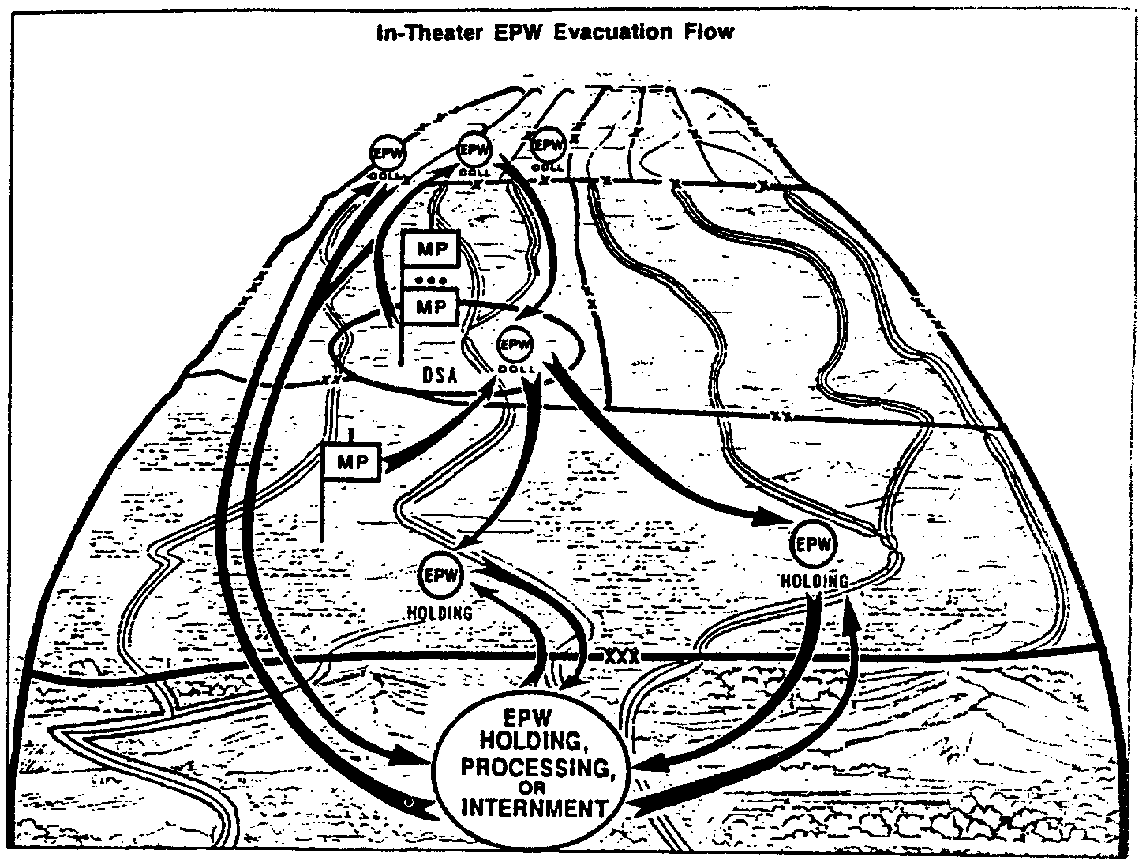

Figure 2-1. Evacuation Flow (EPW).

MP1032 2-4

d. Evacuation Channels.

Evacuation of EPW/CI from the combat zone should be done as quickly as possible. While in the combat zone, EPW/CI may become casualties as the result of enemy fire. The modern battlefield is highly fluid. Units will be widely dispersed and facilities will be austere. The likelihood of prisoners being freed is therefore increased. The fewer there are in the combat zone, the less likely they are to interfere with allied operations.

(1) The normal evacuation channel is from the DFCP to the DCCP. From there, prisoners are evacuated to the CHA. Prisoners are transported from the CHA to a processing facility in the COMMZ. EPW are interned by U.S. forces in the COMMZ, evacuated out of the theater for internment, or transferred to host nation (HN) or Allied Forces for internment separate from EPW. CI may not be evacuated beyond the borders of the territory where they were taken into custody unless we are unable to intern them in the area for material reasons. Prisoners are then released or repatriated at the conclusion of hostilities. They may also be exchanged or repatriated earlier by international agreement.

(2) When the situation permits, any one or more of the steps in the evacuation flow may be skipped. This depends on several factors. The primary considerations are the availability of transportation and escort guards. An additional consideration is interrogation requirements for intelligence purposes. Selected prisoners may be held from corps rearward for intelligence purposes. Such a delay is an exception and lasts only the minimum time necessary to exploit their intelligence value.

EPW/CI may be evacuated by foot, vehicle, rail, aircraft, or ship. The command from which the prisoners are being evacuated is responsible for arranging rations and transportation for the movement. The coordination of all matters affecting the evacuation is also their responsibility. In other words, if corps MP are to pick up prisoners from the division, the arrangements are made by the division.

(3) Escort guards and their transportation are arranged by the command to which the prisoners are being taken. When evacuation is by foot or vehicle, the command usually furnishes the transportation. For example, the guards going forward to the division provide their own transportation. Escort guard MP do not have organic transportation. The transportation for the prisoners is provided by the division.

e. Evacuation Procedures.

(1) The following procedures apply to all modes of transportation:

o Close liaison is maintained with the next higher headquarters. They must be informed of the location of collecting points, other EPW facilities, and the number of prisoners to be evacuated.

2-5 MP1032

o When necessary, stops are made during daylight hours. They should be made away from towns, cities and installations. There is a requirement to avoid public curiosity. This also facilitates the safeguarding of prisoners and lessens the possibility of their being assisted to escape.

o Secondary roads should be used, when possible, to avoid interference with other operations.

o Sufficient rations must be provided for the prisoners. Captured enemy rations should be used as much as possible. Such rations must be checked to ensure they have not become contaminated. Other enemy supplies and material may also be used for the support of the movement.

o Guards should communicate with the prisoners only to issue instructions. Only the minimum essential conversation between guards and prisoners should be permitted. Instructions to the prisoners should be in a language that they understand.

o Punishment for the violation of rules, orders, or regulations is not administered by guards.

o The rules of minimum force always apply.

o The number of escort guards required for a movement will depend on the situation. Factors that must be considered are the morale, physical condition, and number of prisoners involved. Other factors include the mode of transportation, terrain, and probability of enemy attack.

o Guards must be organized and equipped according to the type of transportation that is to be used.

(2) The following principles (see Figure 2-2) are applicable to the specific mode of transportation being used:

o The number of guards needed when evacuating prisoners by aircraft varies. At least two guards are used to evacuate prisoners that are immobilized on a UH-1 or UH-60 helicopter. A minimum of four guards should be used on a CH-47 helicopter. The number of guards depends on the number of prisoners being evacuated and the extent to which they are restrained. Guards must be alert to protect the air crew, as well as maintain order among the prisoners.

o In highway movements, the load limits of the vehicles must not be exceeded. Ideally, fewer prisoners per vehicle should be carried. Some vehicle capacities are as follows:

MP1032 2-6

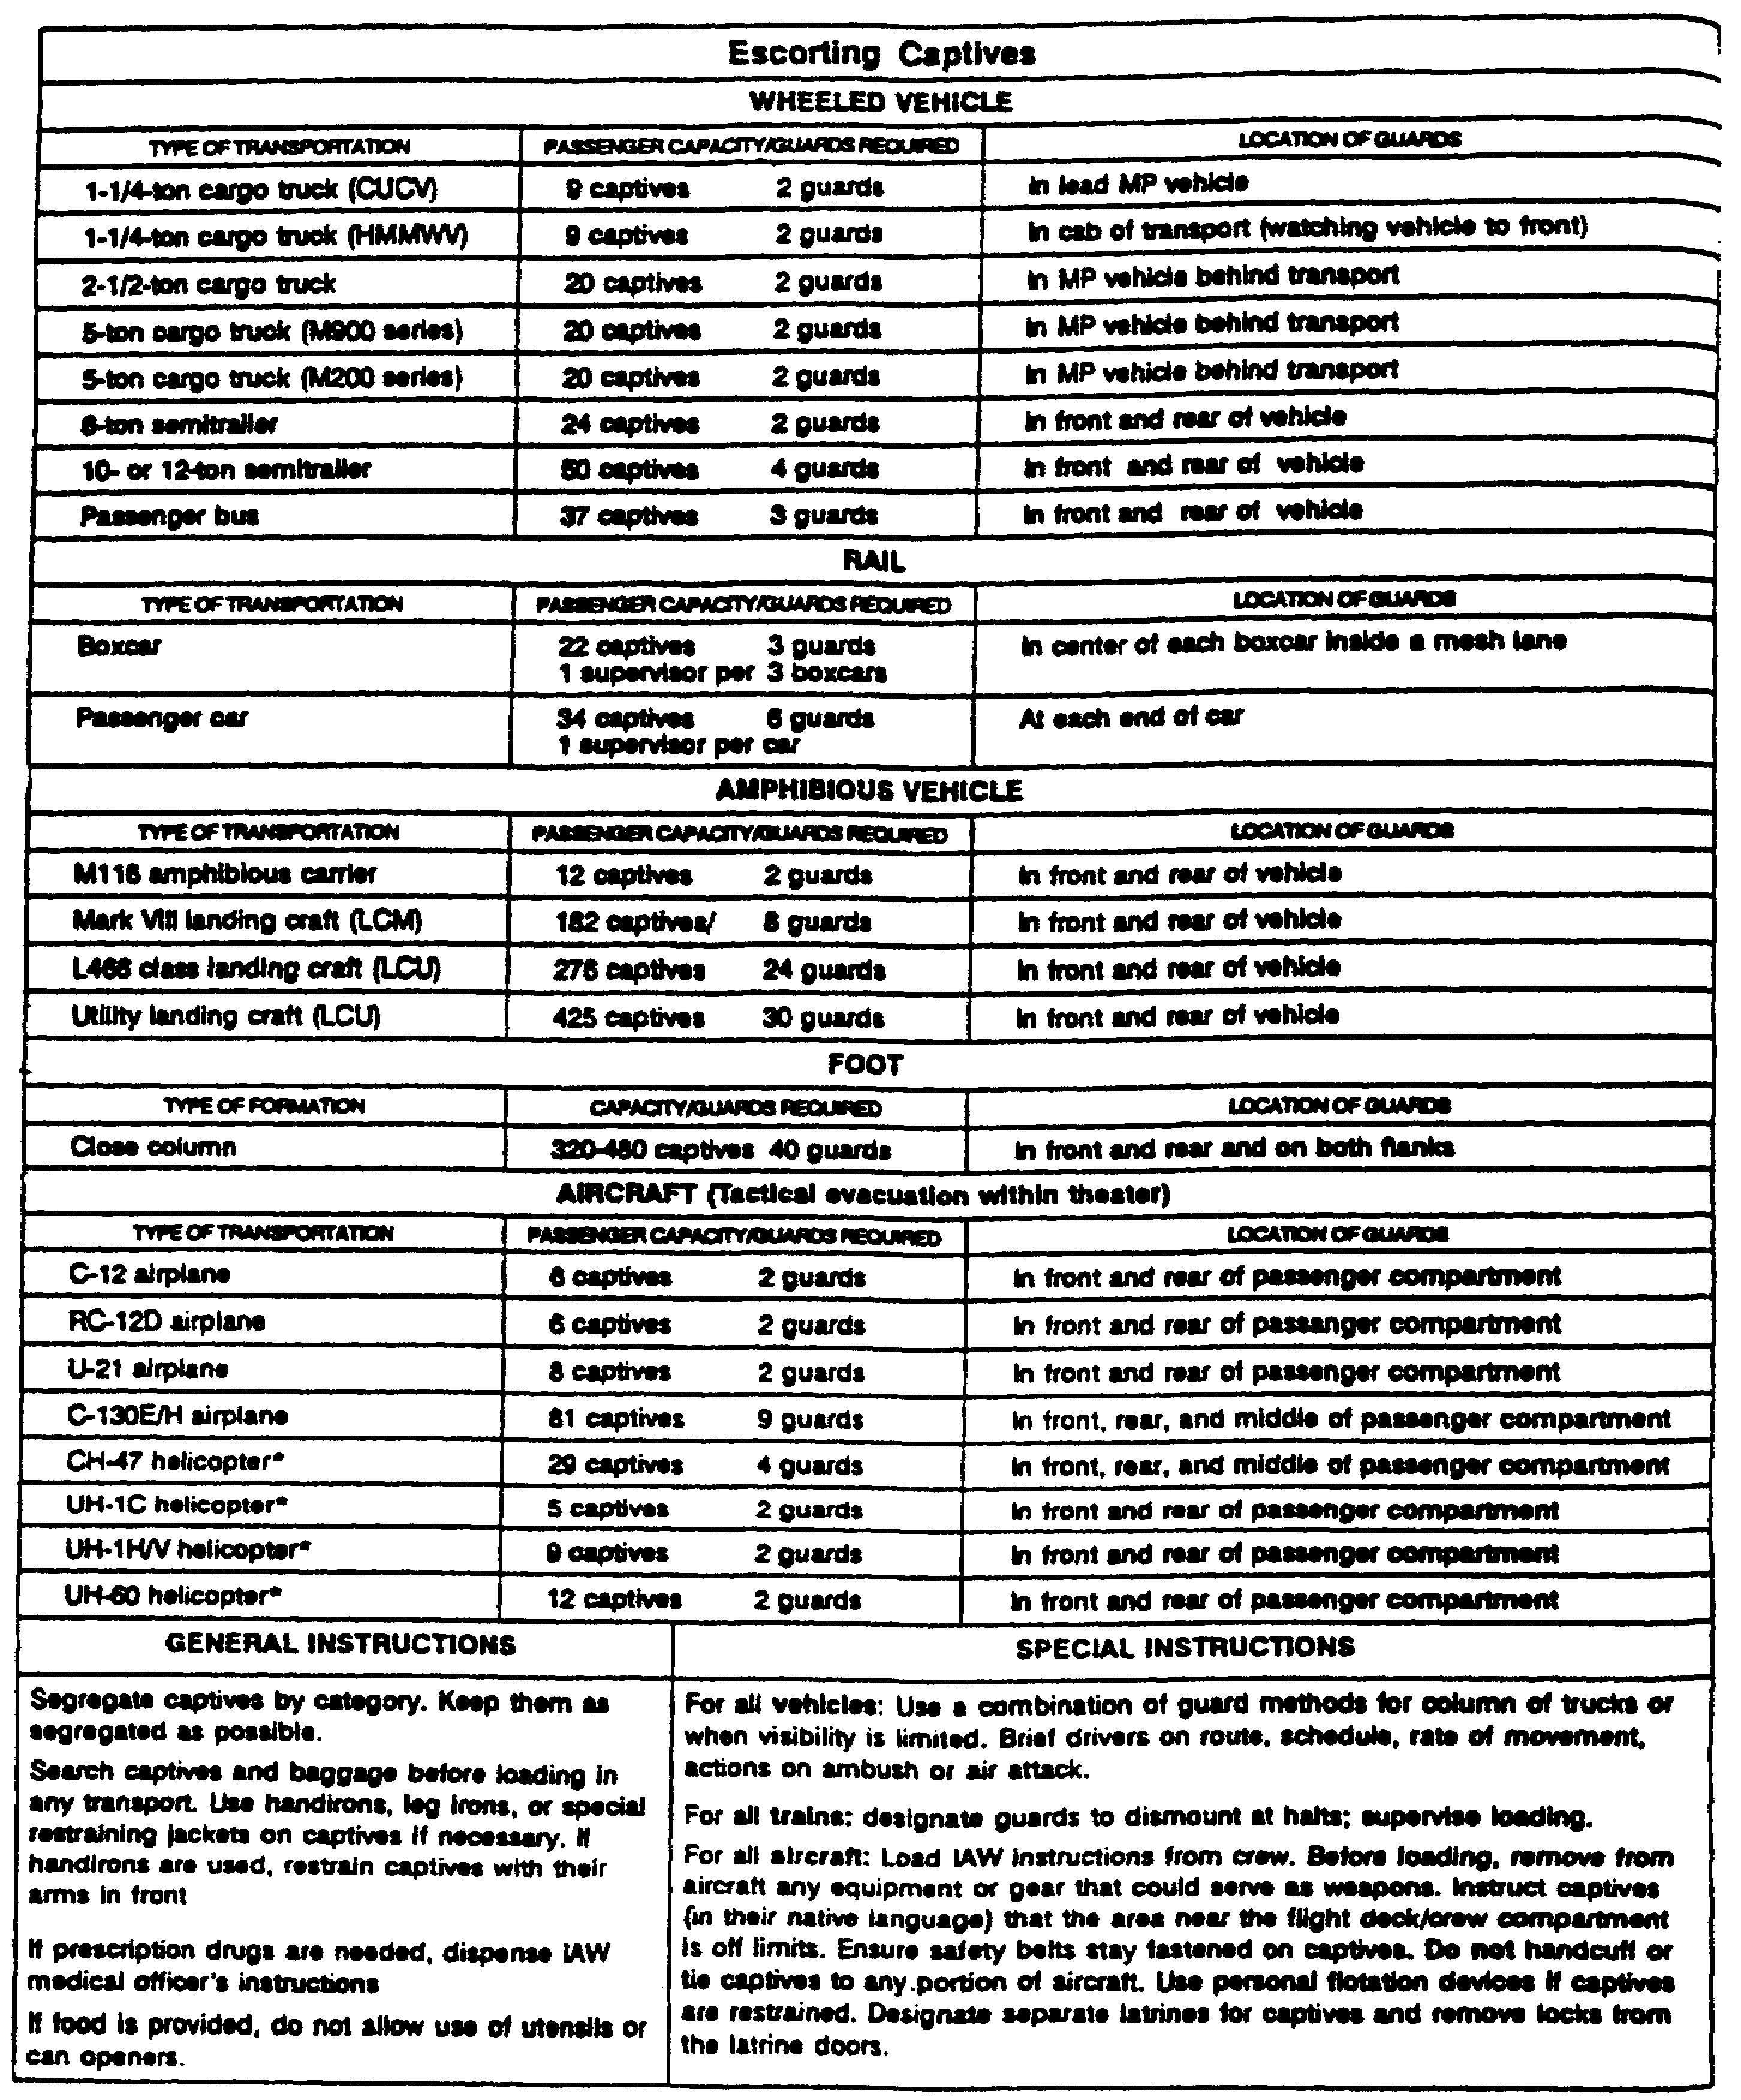

*Load limits for helicopters may change based on the weather and the expected altitude.

Figure 2-2. Escorting Captives.

2-7 MP1032

1 1/4-ton Truck 9 EPW/2 Guards (in lead MP vehicle)
2 1/2-ton Truck 20 EPW/2 Guards (in MP vehicle)
5-ton Truck 20 EPW/2 Guards (behind transport)
12-ton Stake Semi-Trailer 50 EPW/4 Guards (in front and rear
of vehicle)

o A guard may be placed in the cab of each vehicle to guard the prisoners in the vehicle in front. Motor patrols may also be dispersed throughout the column. Helicopters may also be used to overfly the column. This is particularly helpful in rough terrain or through known guerrilla territory.

o When EPW/CI are evacuated by rail, about 34 prisoners may be transported in each passenger car. This will vary depending on the type cars and the length of the move. Each passenger car normally has six guards and a supervisor. Three guards are placed at each end of the car. When boxcars are used, they can normally transport about 22 prisoners each. Three guards are provided per car. They should be in the center of the car, inside a mesh wire lane. One supervisor should be available for each three boxcars.

o When EPW are evacuated by foot (as a last resort), close column formations should be used. Guards should be at the head, rear and both flanks of the column. They space themselves so that each is always in view of at least one other guard. Distance is maintained between the guards and the prisoners.

2. Evacuation Planning.

a. Planning.

(1) The EPW plan prepared by the G1 will normally contain evacuation procedures. Those not included in the plan will be in the appropriate SOP. A major concern is to evacuate prisoners from the combat zone as quickly as possible. Normally, prisoners will not be held in the division longer than 24 hours.

(2) The MP unit in charge of the collecting point (or holding area) tasks the platoon leader to arrange for the evacuation of EPW. The platoon leader arranges for rations and transportation in accordance with the EPW plan and SOP.

(3) The MP company commander receives a tasking from the PM or battalion commander for the evacuation of EPW. He arranges for the guards to evacuate the EPW. This is the MP unit assigned the evacuation mission. For example, a corps MP unit is tasked to evacuate prisoners from the division. The size of the guard detail depends on the situation.

(4) The platoon leader decides how many MP are needed to evacuate the prisoners. He usually gives the mission to a squad leader. Each situation

MP1032 2-8

requires planning and judgment to determine the number of guards required. It also requires very close coordination between the two MP elements involved in the move. Soldiers returning to the rear may be tasked to assist in the evacuation of prisoners.

(5) When the squad leader receives the mission, he begins his troop leading steps. He issues a warning order to his team leaders. Escort personnel are designated. Before they depart on the mission, they must be fully briefed and inspected. Plans for actions to be taken in emergency situations are fully covered. When time permits, such actions should be rehearsed. Units habitually involved in escort missions should train in contingencies at every possible opportunity.

(a) The squad leader conducts a reconnaissance of the route to be followed, whenever possible. When this is not possible, a map reconnaissance is conducted, as a minimum. Of particular concern during the reconnaissance are possible hazard areas, to include ambush sites. The squad leader also should locate rest and halt locations along the route. The terrain along the route will affect the rate of march. It also will affect the number of guards required. Dense woods, jungle, and urban areas require more guards than open areas. The three major areas of concern are the location of friendly units, food and water, and the type of terrain to be traveled.

(b) The location of friendly units that can provide emergency assistance is also noted. When possible, the squad leader coordinates with these units for the assistance ahead of time. Of particular concern is arranging for fire support and medical assistance. Close coordination with MP units on or near the route is also a requirement.

(c) Since EPW evacuation will use secondary routes as much as possible, traffic control will be an important concern. The escort must be prepared to conduct limited traffic control. Assistance may be required from MP units along the route. MP units along the route can also provide a great deal of information about the route. They also may be able to provide back-up support, should it be required.

(d) The squad leader uses a reverse planning sequence to make sure his squad is prepared for the mission. He starts from the pickup time and location and works backward. The location of the collecting point must be verified. The further forward the collecting point is, the more likely it is to move. The number of prisoners to be evacuated should also be verified. Changes in these numbers may require changes in the number of guards. The condition of the prisoners should also be verified. Prisoners that are fatigued and/or cooperative do not require as many guards as those that are more highly motivated.

(e) Close coordination with the unit holding the prisoners is imperative. The type and amount of transportation is arranged by them. This affects the number of guards required, as well as the route to be taken. It also affects the length of time the movement will take. It may be necessary

2-9 MP1032

to coordinate directly with the transportation unit involved. The detail also checks to see that arrangements have been made for rations and water.

(f) Enemy activity along the route must be determined. An area of heavy guerrilla activity will require more guards and perhaps additional weapons. All areas are subject to artillery and air attack.

b. Pick Up Procedures.

Before military police accept responsibility for EPW, they check to see if the prisoners have been processed and are ready for evacuation. They must be searched again. This cannot be overemphasized. In forward areas it is easy to overlook items. Prisoners may also pick up items along the way that may be used as weapons. Prisoners are allowed to keep personal items and protective equipment.

(1) Prisoner tags must be checked. Each prisoner must have a completed tag. Prisoners may destroy tags while in temporary custody so tags must be checked even though the holding unit may have already done so. The tag should state the date, time, and location of capture. It should include the capturing unit and the circumstances of capture. The name of the prisoner, his serial number, and unit should also be included, if possible. Other information may also be included.

(2) Property that has been confiscated should be inventoried. The tag should have the same information as the prisoner tag and a brief description of the item. This includes documents. The description should be sufficient to identify the item. Part C of the standard capture tag (STANAG 2044) is attached to seized property, including documents.

(3) The escort detail leader signs for the prisoners on DD Form 629, or similar form. More than one prisoner may be listed on the form.

The detail leader checks to be sure there are sufficient rations and water for the movement. These are provided by the holding MP unit.

c. Evacuation.

Prisoners can be evacuated on foot, by vehicle, rail, water, or air. Regardless of how the prisoners are moved, certain procedures remain the same. Many of these were discussed earlier in this subcourse. Every effort must be made to keep the prisoners segregated. Conversation with the prisoners is only that required to effect the move.

A military intelligence (MI) or other friendly interpreter may have to give general instructions to the prisoners before they move. Do not use one of the prisoners as an interpreter. The general rules to be followed during the move should be covered. It is also helpful to tell the prisoners what is going on. Detailed information of an intelligence value should not be provided. They can be told that they are to be moved further to the rear for their safety, however. This helps lessen their fear of the unknown and tends to make them a

MP1032 2-10

little more cooperative. The interpreter should cover march discipline, actions in the event of an emergency, and the meaning of the English word "halt." If not already known, the guards may be taught the word "halt" in the language of the prisoners. The final step before departure is to contact the receiving facility. They should be advised of any changes in the number of prisoners or in the route. They should also be given the estimated time of arrival.

d. Vehicle Loading.

When evacuating prisoners by vehicle, loading must be closely supervised. EPW are kept segregated by category as completely as is possible. Various methods may be used to guard prisoners in vehicles. One way is to have a guard in the cab of a vehicle watch prisoners in the vehicle in front. Another is to place a gun jeep behind the truck to watch the prisoners. A combination of these methods may be used.

The escort detail leader must ensure that vehicle drivers are briefed. This briefing includes march discipline, the route, schedule, and rate of march. Each driver is also briefed on what to do in case of emergencies and attacks.

e. Emergencies.

(1) Escapes. Attempted escapes must be expected and prepared for. If a guard sees a prisoner attempting to escape, he shouts "halt!" If the prisoner fails to stop immediately, the guard shouts "halt!" a second time. If the prisoner still does not stop, the command is shouted a third time. After the third time, the guard may open fire. He should only do so if there is no other way to stop the escape. Guards should shoot to wound, unless they are in imminent danger. The remaining guards halt the column and secure the other prisoners.

When prisoners attempt to escape during emergencies, the closest guard recaptures them. The minimum amount of force is used. If the column is moving in vehicles when an escape attempt is made, the convoy stops.

Once the prisoner is recaptured, security around him is increased and the column resumes its movement.

(2) Ambushes. Actions to be taken during ambushes must be planned in advance. Guards should be fully briefed. When possible, the actions to be taken should be rehearsed. One element is designated to control the prisoners. The rest of the guards place maximum fire on the enemy positions. If the detail cannot immediately break out of the ambush, support is requested from nearby units. These units were identified during the reconnaissance and coordinated with ahead of time. When necessary, indirect fires are called for. Reasonable precautions should be taken to protect the prisoners without endangering the guard force or allowing them to escape.

If the column is moving by vehicle, the drivers drive out of the kill zone. Drivers not in the kill zone stop. A predesignated element engages the enemy.

2-11 MP1032

Other guards concentrate on safeguarding the prisoners. Assistance is requested as necessary.

(3) Air Attack. Air attack may be expected throughout the modern battlefield. Guards should have been fully briefed and rehearsed as to what actions to take. One element secures the prisoners. The rest of the guards place the maximum fire possible on the attacking aircraft.

When moving by vehicle, actions are similar. The vehicle moves off the road to the best covered and concealed position available.

(4) Helicopters. Helicopters may be available to transport EPW from collecting points. MP supervise the loading of prisoners on the aircraft. They use the interpreter to explain all the procedures to the prisoners. Guards are placed on each aircraft to secure the prisoners and protect the air crew. Load limits for helicopters may vary with weather conditions and altitude. The final authority for the capacity of the helicopter is the aircraft commander.

Typical load limits are as follows:

o UH1H Iroquois 9 EPW/2 Guards (in front and rear of

o UH60 Blackhawk 12 EPW/2 Guards (passenger compartment)

o CH47D Chinook 29 EPW/4 Guards (in front, rear, and middle of passenger compartment)

(5) Rail Operations. Large numbers of EPW can be evacuated by train. Rail movement is usually not available in the forward areas due to battle damage. Guard requirements have already been discussed. Rail is an economical way of moving large numbers of prisoners with a minimum number of guards. Coordination is made with the train personnel before departure to determine stops. The escort detail leader briefs his men to be especially alert during scheduled stops.

(6) Water Operations. Large numbers of EPW can also be moved by boat/ship. This is particularly feasible in areas of the world with a highly developed water transport system, such as both Eastern and Western Europe. The number of EPW and guards will vary widely depending on the size, capacity, and type of vessel being used. Particular attention must be paid to the dangers of ambush along canals, as well as from underwater mines and swimmers.

f. Release of Prisoners.

The release of the EPW at the destination is a process similar to that at the beginning of the operation. The difference is that the escort detail switches roles. Prisoners are searched. Property is inventoried and signed for. Prisoners are signed for on DD Form 629, or a similar form. Any information that the escort detail has learned during the movement is provided. Such information might be who the leaders are, who tried to escape, and who tried

MP1032 2-12

to talk. The IPW team may want to question the guards about their observations during the movement. This will aid in the further interrogation of the EPW.

2-13 MP1032

LESSON 2

PRACTICE EXERCISE

INTRODUCTION

This practice exercise will show you how much you have learned in this lesson. Select the correct answer to each question. When you are done, turn the page to check your answers.

1. As an MP squad leader, you have been assigned the mission of evacuating a group of EPW from a division central collecting point. Based on this information, you are probably

A. assigned to a division MP DS platoon.
B. assigned to a division MP GS platoon.
C. assigned to a corps MP unit.
D. there is too little information to know.

2. One of your guards feels that one of the EPW is too sick to be evacuated. The MP at the collecting point do not agree. Whose decision resolves this situation?

A. A capturing unit medic.
B. A surgeon from the nearby medical company.
C. A captured doctor.
D. The MP platoon leader.

3. Some of the many items that you must coordinate before escorting EPW include which of the following?

A. Time and date of pick up of EPW.
B. Number of EPW.
C. Location of the collecting point.
D. All of the above.

4. You are evacuating a group of EPW from an airmobile division. They have provided a number of helicopters for this mission. Due to weather conditions, the load has been reduced. Who determines the load capacity of the helicopters?

A. Escort detail leader.
B. Crew chief.
C. Collecting point supervisor.
D. None of the above.

MP1032 2-14

5. You are briefing vehicle drivers that will participate in the movement of EPW. You tell them that if the convoy is ambushed, they should

A. drive out of the kill zone if they are in it.
B. stop only if instructed to do so by you.
C. keep driving on regardless of their position in the convoy.
D. None of the above.

6. Members of your squad have completed searching a group of EPW prior to evacuation from a division collecting point. One of your squad members tells you that he has taken a tape recorder and a fork from one of the prisoners. Which of the following statements is correct?

A. You instruct him to return them to the EPW.
B. An officer must approve this action.
C. The items are tagged and placed with other seized property.
D. You keep the items and return them to the EPW at the corps holding area.

2-15 MP1032

LESSON 2

PRACTICE EXERCISE

ANSWER KEY AND FEEDBACK

ITEM CORRECT ANSWER AND FEEDBACK

1. C. Assigned to a corps MP unit.
The major principle in the evacuation flow of... (page 2-3, para 1c(l)).

2. A. A capturing unit medic.
Medical personnel determine if EPW must be... (page 2-2, para 1b).

3. D. All of the above.
He starts from the pickup time and location... (page 2-9, para 2a(5)(d)).

4. D. None of the above.
The final authority for the capacity of the... (page 2-12, para e(4)).

5. A. Drive out of the kill zone if they are in it.
If the column is moving by vehicle, the... (page 2-11, para e(2)).

6. C. The items are tagged and placed with other seized property.
The exception to this are equipment... (page 2-3, para c(2)).

MP1032 2-16

LESSON 3

SUPERVISE THE PROCESSING OF EPW/CI AT AN EPW FACILITY

Critical Task: 191-379-4413

OVERVIEW

LESSON DESCRIPTION:

In this lesson you will learn to supervise the processing of EPW/CI at an EPW facility.

TERMINAL LEARNING OBJECTIVE:

ACTION: Supervise the processing of EPW/CI at an EPW facility.

CONDITIONS: You will have this subcourse, pencil and paper.

STANDARD: Evaluation of your performance will be by successful completion of the examination (70 percent).

REFERENCES: The material contained in this lesson was derived from the following publications: AR 37-36, AR 190-8, FM 19-40, FM 19-1, and FM 19-4.

INTRODUCTION

1. General.

The basic U.S. policy on the treatment of EPW continues to apply through all stages of their handling. This treatment begins at the point of capture and does not end until EPW have been released or repatriated. Basic U.S. policy can be found in the introduction to this subcourse.

The evacuation of EPW/CI does not end at the CHA. Leaders assigned to an MP company in the COMMZ may be tasked to evacuate prisoners from the CHA, or directly from division collecting points. The procedures they follow are the same as those covered in Lesson 2.

EPW/CI internment is the confining or enclosing of EPW/CI in the COMMZ. EPW may also be transferred to host nation or allied forces for internment. CI are not normally evacuated beyond the borders of the territory they were found in.

3-1 MP1032

2. Evacuation.

a. The Theater Army Area Command (TAACOM) commander is responsible for the prompt evacuation of EPW from the supported corps. These responsibilities are carried out for him by the MP PW brigade commander. MP EPW command or brigade may provide escort guards for the movement. They will also establish transit facilities for overnight stops if they are required. One or more of the PW camps may be designated for the reception and administrative processing of the EPW evacuated from the combat zone.

b. EPW are evacuated from corps holding areas by Theater Army MP. Escort guard MP are used when possible. When the ability of escort guard MP is exceeded, other Theater Army MP assets are used. The procedures followed by these escort guards are essentially the same as those described in Lesson 2. The major difference is in the volume of prisoners that they handle.

c. Often, the MP PW brigade will provide liaison officers at the corps holding areas. This enhances coordination and cooperation. It permits more prompt response to the need for evacuation. The escort guard companies may also dispatch teams of escort guards to the corps holding areas on a "stand-by" basis. This can only be done when there are sufficient personnel available and when the capture rate is high enough to make it worthwhile. Mass transportation is used whenever possible. This causes less interference with other operations and makes maximum use of available transportation. It also allows a maximum number of prisoners to be moved by a minimum number of guards. Movement of EPW/CI should be accomplished over secondary routes whenever possible. This is to prevent interference with logistical and other operations. However, EPW must not be held for excessive periods of time simply to gather a larger group.

PART A - ORGANIZATIONS

1. Theater Army EPW and CI Organizations.

a. While much of this subcourse has been written with reference to the "H" series Table of Organization and Equipment (TOE), the following is a discussion of the newer "L" series TOE which will replace these. Basic policy and procedure remain essentially the same. When it does differ, that information has been provided in the text.

b. The Theater Army (TA) commander is responsible for evacuating EPW from supported corps. This responsibility includes providing guards and establishing and operating transient facilities when overnight stops are required. The TA commander is also responsible for EPW and CI facilities in the communications zone (COMMZ).

2. HHC, MP EPW Brigade (TOE 19-762L).

a. The highest command and control element for MP EPW and CI units at TA level is the HHC, MP EPW brigade. The HHC, MP EPW brigade is assigned to the

MP1032 3-2

Theater Army Headquarters Area Command (TAACOM) or a Personnel Command (PERSCOM), TOE 12602L.

b. At level one, this unit.

o Commands and controls two to seven EPW and CI battalions (TOE-19-646L).

o Plans and supervises EPW and CI collection and evacuation operations.

o Coordinates with host nation (HN) authorities on matters pertaining to EPW and CI.

c. The MP EPW brigade depends upon TAACOM units for health services, finance, personnel and administrative services, transportation, interpreters, and maintenance. The EPW brigade is authorized at one per TAACOM, one per contingency or as required.

3. Command and Control Detachment (TOE 19-543-LH).

a. The highest command and control element for MP EPW and CI units, at TA level when an MP EPW brigade is not authorized, is the command and control detachment. The command and control detachment is assigned to the TA MP brigade (TOE 19-172L). At level one, the command and control detachment:

o Commands and controls two or three EPW and CI battalions (TOE 19-646L) processing and interning less than 12,000 EPW and CI.

o Plans and supervises TA EPW and CI collection, evacuation, and internment operations.

b. The command and control detachment depends upon TAACOM units for health services, finance, personnel and administrative services, transportation, interpreters, and maintenance. The command and control detachment is not authorized in a theater when less than two EPW and CI battalions are assigned.

4. MP EPW and CI Battalion (TOE 19-646L).

a. The EPW and CI battalion accomplishes the same mission, and replaces the MP PW processing company (TOE 19-237H) and the MP PW camp (19-256H). The EPW and CI battalion is assigned to the MP brigade; or to a MP Prisoner of War Command.

b. The EPW and CI battalion is assigned to the MP EPW brigade in large, mature theaters when more than 12,000 EPW and CI are processed and evacuated; to the command and control detachment when two or three battalions process, evacuate, and intern less than 12,000 EPW and CI; and to the TA MP brigade when only one EPW and CI battalion is assigned to process and evacuate prisoners.

3-3 MP1032

c. The MP EPW and CI battalion is structured at four levels: TOE 19-646L100, L200, L300, and L400. Each TOE is capable of handling a different number of EPW and CI. The L100 battalion is capable of handling 1,000 EPW or CI; the L200 battalion can handle 2,000 EPW or CI; the L300 can handle 3,000 EPW and CI; and the L400 battalion can handle 4,000 EPW or CI.

(1) At level one, the EPW and CI battalion provides:

o Command and control, and administrative and logistic support for one enclosure holding 1,000 to 4,000 EPW and CI.

o Command, staff planning, and supervision of assigned and attached units.

o Food, clothing, religious, and recreational support to EPW and CI.

o Utilities, including heat, light, water, cooking, and sanitation facilities.

o Health services support and preventive medicine services to EPW and CI, including supervision of appropriate retained personnel.

o Supervision of subordinate unit's organization supply, communications, and unit maintenance.

o Supervision and assistance to subordinate units in training and administration.

o Staff supervision of EPW collection and evacuation operations.

o Internal FM and wire communications net.

o Personnel and finance sections capable of in-processing eight EPW and CI records per hour, and maintaining up to 4,000 records per month.

o Supervision of work projects of EPW/CI.

(2) The MP EPW and CI battalion depends on TAACOM units for:

o Health service support and medical equipment maintenance.

o Engineer, finance, personnel, and administrative services.

o Transportation of EPW and CI.

o Water purification services and supply (classes I through IX).

MP1032 3-4

5. MP Guard Company (TOE 19-667L).

a. The MP guard company provides guards for EPW and CI or for U.S. military prisoners installations and facilities. The MP guard company is assigned to the EPW facility, MP confinement battalion, MP battalion, or the railway operations battalion.

b. At level one, on a 24 hour basis, the MP guard company can provide guards for enclosures with up to 2,000 EPW and CI. The MP guard company assists in the defense of the EPW and CI battalion area, and provides maintenance on organic equipment (except power generators).

The MP guard company depends on the EPW and CI battalion and other TAACOM units for:

o Health services.

o Religious, legal, finance, and personnel and administrative services.

o Maintenance of power generators.

6. MP Escort Guard Company (TOE 19-647L).

The MP escort guard company provides personnel to supervise and secure EPW and CI during movement in the COMMZ. The MP escort guard company is assigned to the EPW and CI brigade (when a brigade is authorized); or an EPW and CI battalion in theaters where an EPW and CI brigade is not authorized.

At level one, the MP escort guard company provides security for the following number of EPW and CI during movement:

o Marching 1,000 to 1,500

o Vehicle 1,500 to 2,000

o Rail 2,000 to 4,000

The MP escort guard company does not have organic transportation for guard squads or teams. Transportation for movement of MP assigned to the guard company to evacuate EPW and CI must be arranged as it is for prisoners.

The unit assists in defense of the unit area and is capable of maintaining organic equipment. The MP escort guard company depends upon the unit that it is assigned to, and other TAACOM units for: health, religious, finance, food, and personnel and administrative services; transportation to move guards and EPW and CI, and unit maintenance of power generation equipment.

3-5 MP1032

7. Branch Prisoner of War Information Center (TOE 19-643L).

The branch Prisoner of War Information Center (PWIC) accounts for U.S. captured EPW, CI, and maintains information about U.S. soldiers who are captured by the enemy or are missing in action. The branch PWIC is assigned to the MP EPW brigade, or the TA MP brigade (when an EPW brigade is not authorized).

At level one, the branch PWIC:

o Collects, processes and reports information received from U.S. EPW and CI facilities. This includes information about U.S. captured EPW that were transferred to HN or allied forces for internment.

o Receives, documents, and reports information about U.S. soldiers and civilians who are missing or held by the enemy.

o Receives, stores, and disposes of personal property belonging to EPW and CI that have died, escaped, or been repatriated. This includes property belonging to enemy soldiers killed in action that was not disposed of in graves registration channels.

o Maintains a central location system for U.S. captured EPW and CI that were transferred to HN or allied forces for internment.

The branch PWIC depends on the unit it is assigned to and other TA units for:

o Food services and water.

o Health, legal, religious, finance, and personnel and administrative services.

o Supply support (classes I through IX).

o Transportation of organic equipment and assigned and attached personnel.

o Maintenance of automatic data processing equipment, power generators, and communications-electronic equipment.

8. EPW and CI Command Liaison Detachment (TOE 19-543LD).

The EPW and CI command liaison detachment provides command, control, and supervision of MP EPW and CI liaison teams. It provides staff planning and coordinating link from the TA commander to HN or allied prisoner of war command staff. The EPW and CI liaison detachment is assigned to the TA MP brigade.

9. EPW and CI Branch Camp Liaison Team (TOE 19-543LE).

The EPW and CI branch camp liaison team provides a coordinating link between the TA commander and HN or allied EPW facilities holding U.S. captured EPW.

MP1032 3-6

The branch camp liaison teams ensure that U.S. captured EPW transferred to HN or allied forces for internment are treated according to U.S. policy and the Geneva Conventions and protocols.

One branch camp liaison team is authorized for each HN or allied camp holding U.S. captured EPW. The branch camp liaison team is assigned to the EPW and CI command and control detachment.

10. EPW and CI Processing and Liaison Team (TOE 19-543LG).

The processing liaison team provides a coordinating link between the TA commander and an HN or allied force processing point. One processing point liaison team is authorized for every HN or allied force processing point designated to accept custody of U.S. captured EPW and CI for internment. Processing point liaison teams are assigned to the EPW and CI command liaison detachment.

11. EPW and CI Information Center Liaison Team (TOE 10-543LF).

The information center liaison team provides a coordinating link between the TA commander and an HN or allied force national prisoner of war information center. The information center liaison team monitors the records of U.S. captured EPW and CI interned by HN or allied forces. The information center liaison team is assigned to the EPW and CI command liaison detachment.

12. Support Required by Liaison Teams and Detachments.

Liaison detachments and teams depend on other TAACOM units for:

o Health, legal, religious, finance, and personnel and administrative services.

o Supply support (classes I through IX).

o Transportation of personnel and equipment.

o Maintenance of organic equipment.

o Food service support.

PART B - RECEPTION FACILITY OPERATIONS

1. Facility Location and Designation.

The MP PW brigade commander may designate one or more facilities to receive and begin the processing of EPW. This depends on the particular theater size of the COMMZ, and the volume of prisoners. The brigade commander and his staff must consider the capabilities of the transportation net and the number of evacuation terminals in making this decision. The minimum number of facilities are designated to receive prisoners. This allows for centralization of initial processing activities and is more efficient. These

3-7 MP1032

facilities will be located near designated transportation terminals. The remainder of the facilities are located toward the rear of the COMMZ. They receive prisoners from the reception facility for internment.

2. Organization of Reception Facilities.

a. The facility or facilities designated for central reception and processing differs from the other facilities. The major difference is the absence of internment capability.

Such a facility is designed to receive, search, and process EPW/CI. It will also prepare and process reports and records, assign internment serial numbers; and provide information to the U.S. Branch PW Information Center. Under normal circumstances, the facility can process about 90 EPW per hour.

All the EPW/CI received at the facility are normally transferred to other facilities in the COMMZ or evacuated to the United States. An exception is that some EPW may be kept to help in the operation and maintenance of the facility. This will normally be a very limited number. The processing of selected individuals, and their transfer to internment facilities, may also be delayed for intelligence interrogations.

b. A special medical team will be attached. This medical team will perform medical processing actions. These include immunizations, medical examinations, and initiating medical records. The team may also assist in disinfestations.

Another medical team may be attached to train and supervise some of the EPW in performing delousing and disinfestation. The team chief of this team coordinates all such actions with the camp medical officer and camp commander.

3. Reception and Processing.

a. Reception.

EPW/CI may arrive at the facility at any hour of the day or night. The facility will normally know ahead of time. They must be prepared, however, to in-process prisoners at any time. Upon arrival, STRESS again applies. The prisoners will be searched and signed for on DD Form 629. Property will also be inventoried and signed for on DA Form 4137. Food, water, and shelter must be provided. Emergency medical care will be provided those needing it.

Incoming prisoners are kept segregated from those that have arrived earlier. This is primarily for medical and administrative reasons. It also aids in the safeguarding of the EPW. The segregation by category within the arriving group is also maintained. This segregation should be maintained throughout the processing if at all possible.

b. Processing.

MP1032 3-8

(1) Processing is normally accomplished within 24 to 48 hours. The intent is to move the EPW through the processing system and to their internment location as quickly as possible. This is accomplished without compromising completeness or accuracy. How quickly it can be accomplished will depend on the number of prisoners, when they arrive, and the availability of guards and transportation to move them to the internment camp. Initial reception will include the following, as required:

o Haircut, shower, shave.

o Lindane dusting.

o Initial immunizations.

o Physical inspection.

o Issuance of clean clothing and toilet articles, mess equipment and blankets.

o Preparation of a personnel record (DA Form 4237-R Detainee Personnel Record).

o Completion of a fingerprint card.

o Issuance of an identity card/identification band.

o Assignment of an internment serial number.

(2) Each EPW will have a DA Form 4237-R (Detainee Personnel Record) completed at the processing camp. Once the form is completed, one copy will accompany the EPW to the internment camp, and any subsequent transfers. One copy is provided the PW Branch Information Center (PWIC). Figure 3-1 is an example of this form.

(3) Hospitalized prisoners are processed as soon as their medical condition permits. Full recovery is not required. Processing that can be accomplished is done as early as possible. Qualified medical officers determine the ability of the hospitalized EPW to be processed.

(4) Formal accountability is considered to have been established when the records are completed and an internment serial number (ISN) assigned. The effective date of accountability is when DA Form 4237-R, Detainee Personnel Record, has been accomplished. The reception camp then submits DA Form 2674-R, Internee Strength Report.

(5) The ISN is as its name implies. It is essentially a serial number assigned to each EPW, just as any U.S. soldier has a serial number (SSN). Each ISN is unique to the individual EPW. The ISN consists of two parts separated by a dash. The first part contains three symbols. The first symbol is “US”. The second is a letter or number indicating the command under which the EPW came into U.S. custody. The third symbol indicates the country

3-9 MP1032

in whose military the EPW was serving. The second part of the ISN will be a number, followed by the letters EPW, RP, or CI, depending upon status. It is a five-digit number assigned at the processing camp. The camp uses the numbers, in sequence, provided in block by the PWIS.

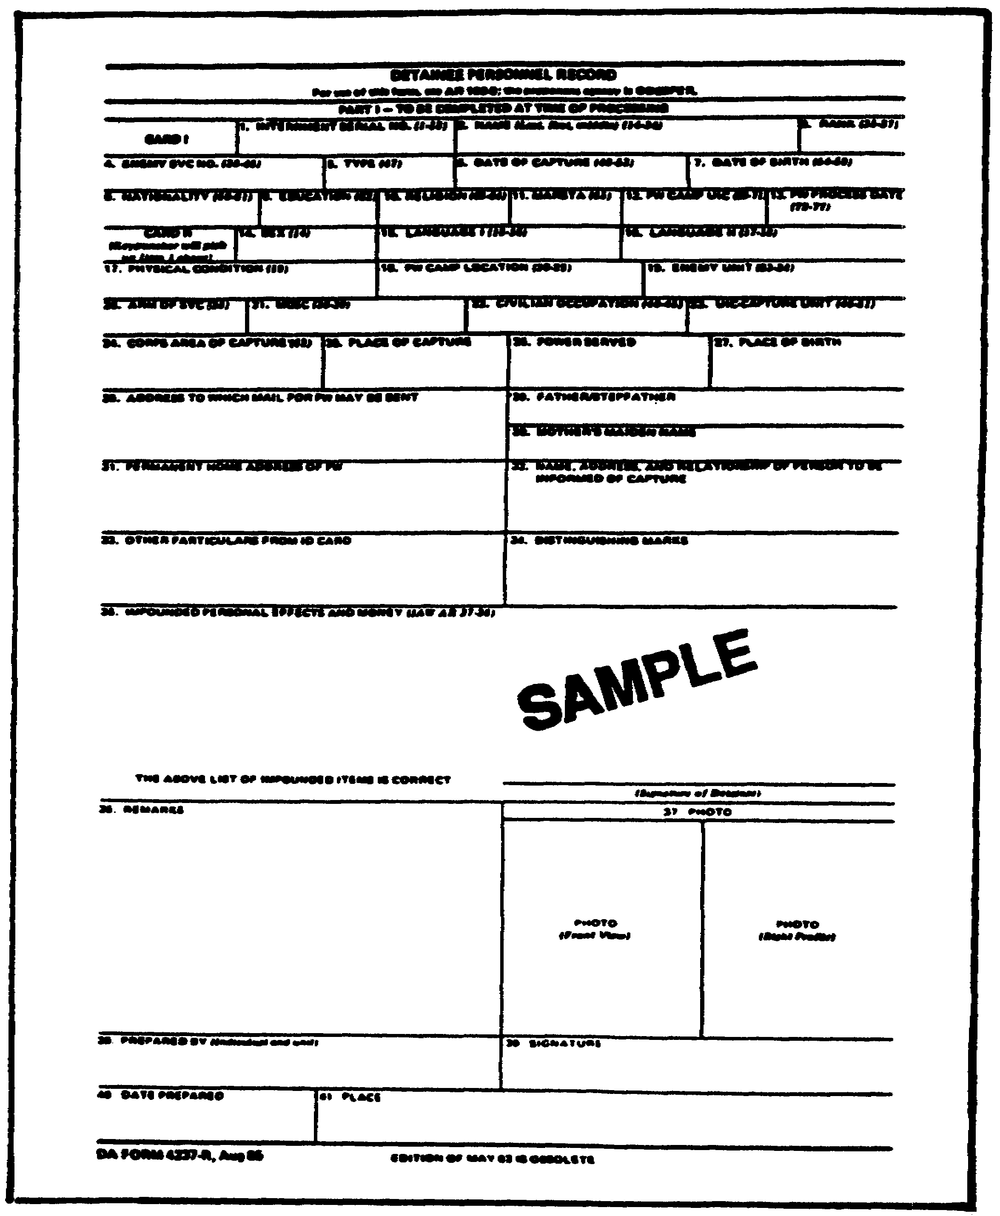

Figure 3-1. DA Form 4237-R, Detainee Personnel Record.

MP1032 3-10

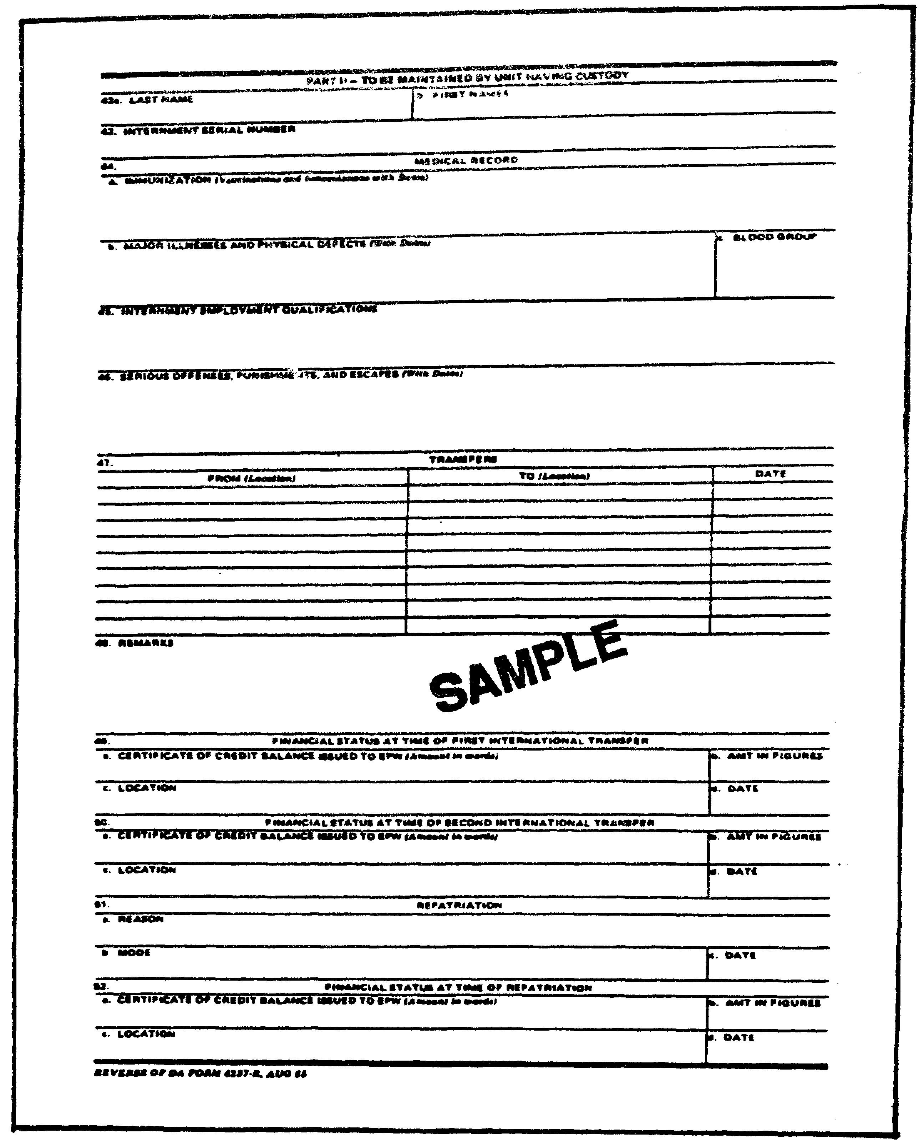

Figure 3-1. DA Form 4237-R (Continued).

3-11 MP1032

(6) EPW are permitted to send a DA Form 2666-R (Prisoner of War Notification of Address) to a relative or next of kin. CIs are permitted to send a DA Form 2678-R (CI Notification of Address). Notifications are mailed after the Detainee Personnel Record (DA Form 4237-R) is completed but not later than one week after arrival at a camp for processing. Prisoners are also permitted to send mail to a relative or next of kin. DA Forms 2667-R (PW Mail), 2668-R (Post Card), 2679-R (Civilian Internee Mail), and 2680-R (Civilian Internee Post Card) are used for this purpose. This may be delayed, but in no case for longer than one week.

(7) Identity cards issued by the EPW's country may not be taken from him. He may, however, be required to show such an identity card. When the EPW has no identity card, he will be issued DA Form 2662-R (United :States Army EPW Identity Card). The EPW is required to keep the ID card in his possession at all times. Figure 3-2 is an illustration of this form. CIs are issued DA Form 2677-R (Civilian Internee Identification Card) under the same circumstances.

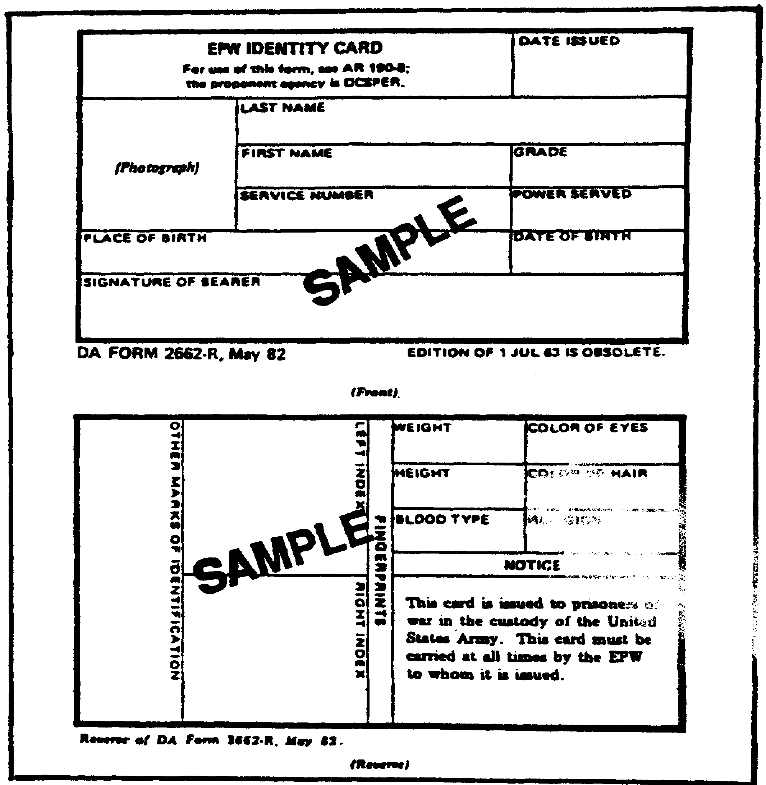

Figure 3-2. DA Form 2662-R, EPW Identity Card.

MP1032 3-12

(8) A fingerprint card (DA Form 2663-R) will be prepared in two copies for each EPW. One copy accompanies the EPW to the internment facility and any subsequent transfers. The second copy is provided the PWIS.

4. Classification.

During the course of their administrative processing, EPW are further identified, classified and segregated. They are segregated according to status as retained persons, CI, and EPW. They are also segregated as officers, NCO, and enlisted personnel, deserters, sex, nationality, and language. Additional categories may also be developed depending on the area of the world and other factors. This may include segregation for security purposes. It may also be based on ideology. In some cases, there may be violently clashing ideologies which require keeping certain prisoners separated from each other. Selected ideologues may also be trouble-makers and should be segregated from the other prisoners.

Those individuals that refuse to reveal their military or civilian status are classified as unknowns. They are segregated from the other prisoners for later interrogation and identification.

5. Assignment and Segregation.

The PW brigade provides assignment instructions. These instructions indicate the number and status of prisoners to be transferred to specific facilities. Based on these instructions, the reception facility assigns specific prisoners to specific facilities. Various categories may be assigned to the same facilities. Within that facility, they will be segregated by their status into different compounds. Where there are conflicting ideologies, or similar situations, the reception facility will be provided special instructions. CI are separated from EPW and are sent only to CI facilities.

When processing is completed, escort guards assigned to the facility transfer the prisoners to the assigned internment facility. The process used is the same as for all other transfers.

PART C - INTERNMENT FACILITIES

1. Command Responsibilities.

Every internment facility is under the command of a commissioned officer. Copies of the Geneva Convention of 1949 must be posted in each camp. They must be readily accessible to the prisoners and must be in a language understood by them. All regulations, orders, and notices relating to prisoner conduct and activities must be similarly posted (see Figure 3-3).

Under the Geneva Convention, prisoners have certain rights. Most important of these, along with others that have already been mentioned, are:

3-13 MP1032

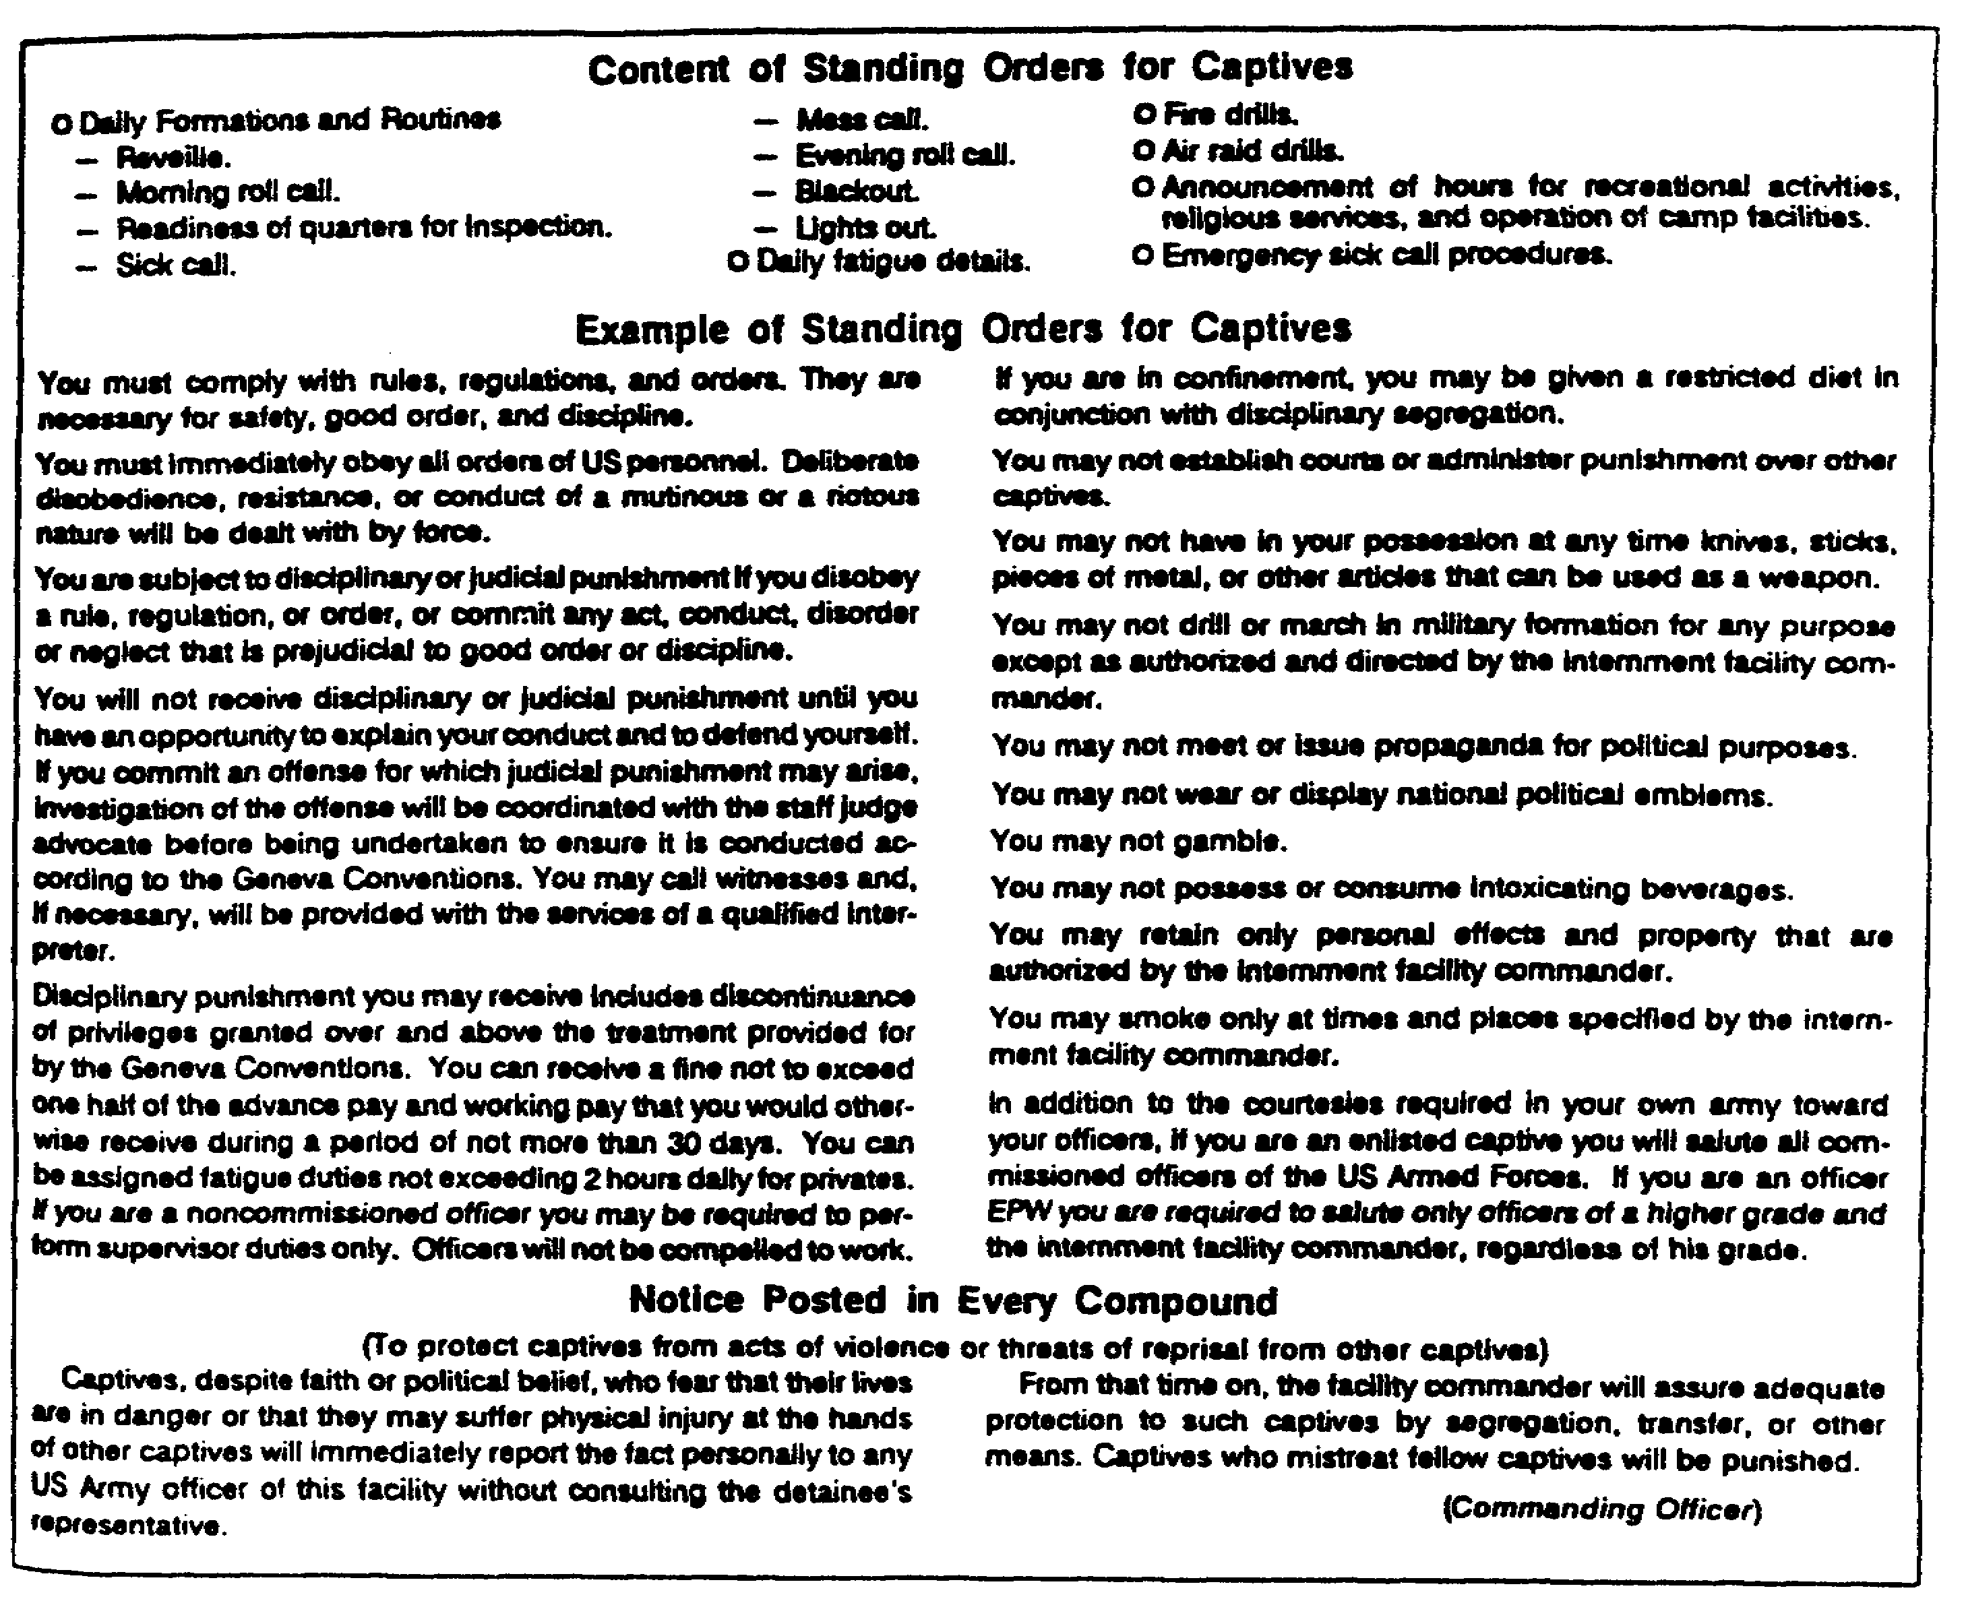

Figure 3-3. Content of Standing Orders for Captives.

o Protest conditions of confinement.

o Under certain conditions, elect their own representatives (see below).

o Send and receive correspondence.

o Notification of the protecting power of their status.

When EPW are interned in facilities where there are no officers, they may elect a representative. The representatives are elected every six months by secret ballot. In officer camps, or in camps with officers and enlisted persons, the senior officer is the prisoner representative. One or more advisors to the senior officer may be elected.

MP1032 3-14

2. Types of Internment Facilities.

a. An EPW internment facility is a semipermanent installation. It is for the internment and complete administration of EPW. It has a MP company attached that provides guard services. Each facility is subdivided into four compounds. A compound is capable of holding up to 500 EPW/CI. Figure 3-4 is an illustration of a type facility.

b. A branch compound is a subdivision of a facility that is located away from the main facility. It is used to supervise labor details located away from the main facility for extended periods. A branch compound usually holds from 250 to 500 EPW.

3. Facility Location.

In the COMMZ, main facilities are located toward the rear of the COMMZ. They are near railways, airports, medical facilities, and transportation centers. Facilities must not be located in areas that will endanger the prisoners. This includes not only enemy attack, but also areas of a potential health threat, such as swamps and marshes. They must also be near an adequate water source for the number of persons interned. When it is intended to use the EPW as a source of labor, the facility should be located in close proximity to the place where the prisoners will work. Generally, facilities should be located away from population centers as well.

4. Administration.

Initial processing is accomplished by the PW processing company at the designated reception facility. Each facility is required to complete a daily report on prisoner strength to the U.S. Branch PW Information Center located in the theater. This daily strength report is done on DA Form 2674-R (Figure 3-5). Formal accountability for prisoners begins at the reception facility and is continued until the EPW is released or repatriated. EPW must be permitted, within one week of their arrival, to notify the International Red Cross of their location. When they are later transferred, they are permitted to notify their next of kin. This is accomplished on DA Form 2666-R.

a. General Principles:

The following general principles are followed in EPW facilities:

o EPW are used for the internal administration and operation of the facilities to the maximum extent possible.

o Captured enemy supplies and equipment are used for the support of EPW as much as possible.

3-15 MP1032

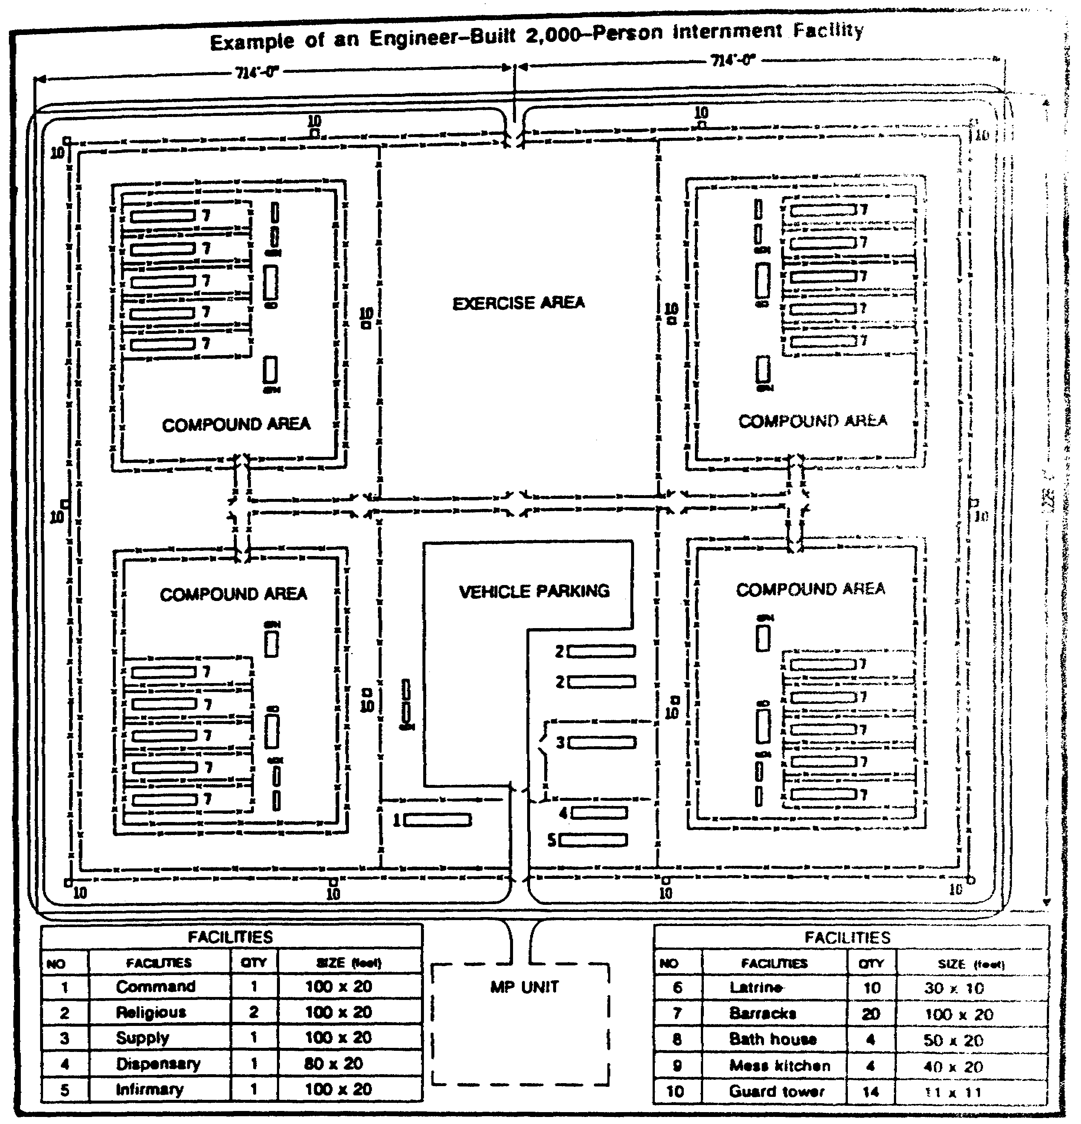

Figure 3-4. EPW/CI Enclosure.

MP1032 3-16

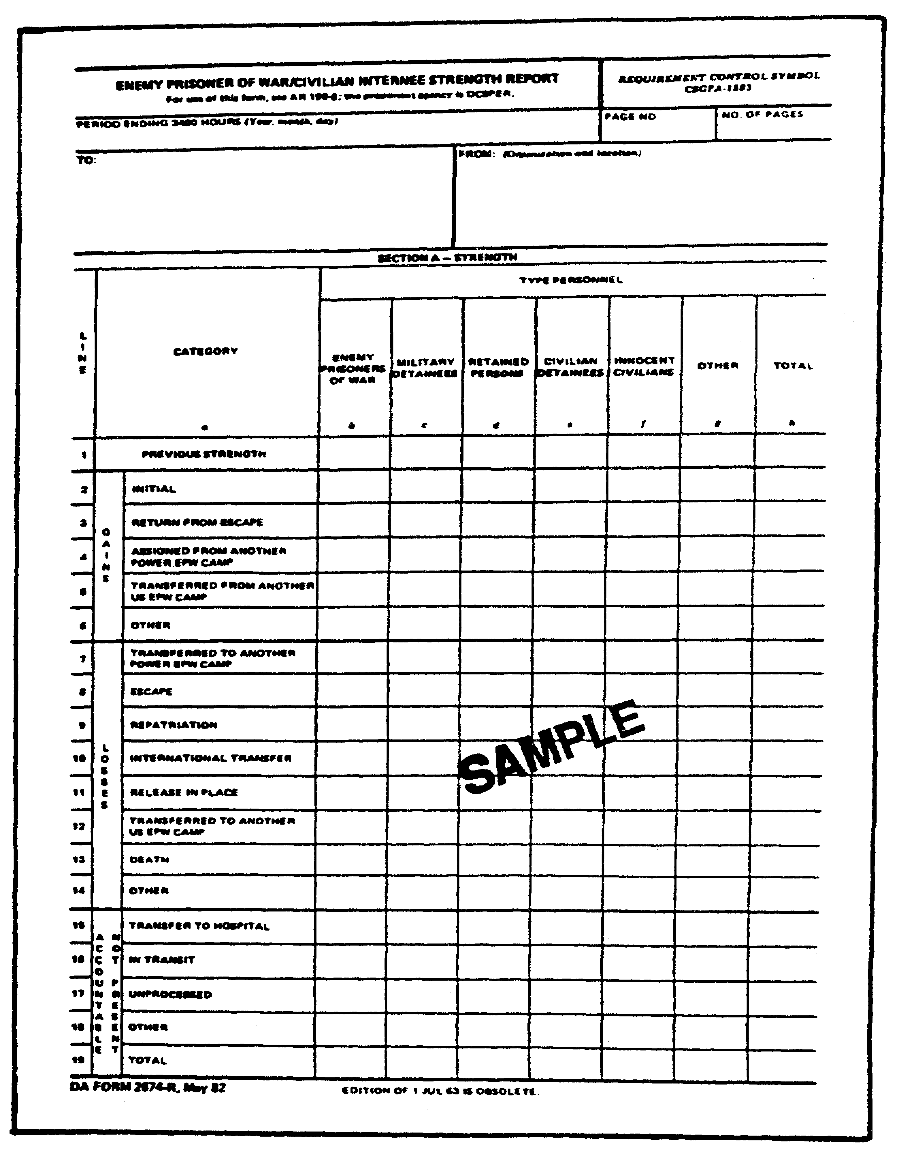

Figure 3-5. DA Form 2674-R.

3-17 MP1032

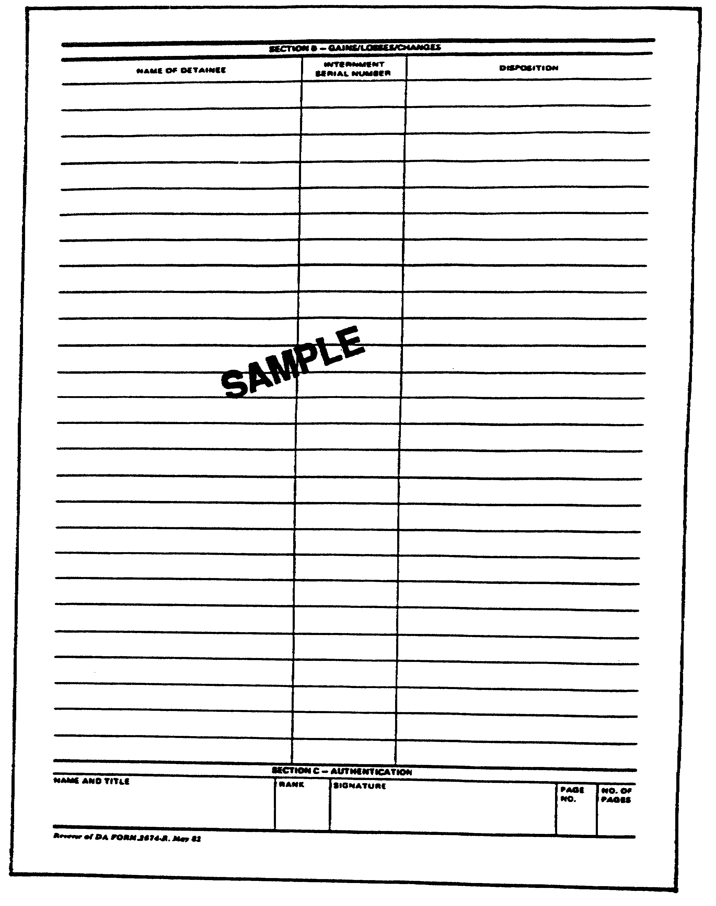

Figure 3-5. DA Form 2674-R (continued).

MP1032 3-18

b. Classification and Assignment.

(1) The initial internment classification is made at the processing camp. It is usually a confirmation of the classification made in the combat zone. EPW may be reclassified based on the availability of additional or new information.

Once prisoners reach the internment facility, they may again be reclassified. The initial classification is often made based on unsupported statements of the prisoner and/or on documents he may have in his possession. Subsequent information and verification may require changing his classification. Much of this information will come from the observation of his actions and from interrogations and cross checks.

(2) Within the facility, prisoners are assigned based on their classification. Segregation is maintained and constantly refined.

(3) EPW are interned according to their nationality and language. Regardless of this, they are never separated from other prisoners belonging to the same armed forces in which they were serving, except with their consent. For example, a German serving in the French Army would remain with French Army EPW. He would be moved to a compound with other Germans only with his consent. On the other hand, all Polish speaking EPW could be consolidated in one location if they all served in the Soviet Army. Female detainees are always separated from males.

(4) EPW are also separated and receive treatment according to their grade. EPW that claim officer or NCO status, but cannot prove that status, are classified as enlisted personnel; the theater commander and Department of the Army have the authority to grant such status to an EPW that cannot otherwise prove his rank. EPW may also request through channels that their government substantiate their rank.

(5) Officers are separated from enlisted personnel. This may be in separate facilities, or in enclosures or compounds within a facility. They are provided facilities appropriate to their grade.

c. PW Identification Band.

Upon arrival at the facility, the internment serial number (ISN) is verified. Should a prisoner arrive without an ISN, one is assigned. The ISN and the individual's last name are recorded on a prisoner identification band. The band is attached to the left wrist of the prisoner. This is accomplished at the reception facility during the processing of the prisoner.

Varied colored bands are used for different categories of prisoners. The colors to be used will be prescribed by local SOP. For example, retained personnel get one color, officers another. The determination of the colors and their use is to aid in control and administration.

3-19 MP1032

The identification band is designed so that when properly used it cannot be removed without destroying it. The average life expectancy of a band is about 6 months. This will vary widely, depending on the activity of the prisoner, weather conditions, and other such factors. Bands should be inspected regularly. It is possible for them to be exchanged among prisoners, but not without causing damage to the band.

d. Personal Property and Equipment.

(1) All personal effects of EPW will be safeguarded. This includes money and other valuables. Any such effects taken from them temporarily for intelligence purposes will be signed for and returned to them as soon as possible. Protective gear, such as protective masks and helmets, will be retained by the EPW. The identification card will not be taken from the person at any time.

(2) The commanding officer of the camp where the EPW is interned will be responsible for storing and safekeeping impounded personal effects. Such property will be marked or otherwise identified. When necessary, the property will be securely bound or packaged. Upon transfer, the impounded property will be delivered to the commanding officer of the receiving facility.

(3) An inventory of personal effects that have been impounded will be entered on DA Form 4237-R. Also, at the time of processing, DA Form 1132 (Prisoner's Personal Property List - Personal Deposit Fund) will be completed and signed by the officer in charge or authorized representative. A copy will be provided the person.

(4) DA Form 1132 will be completed by typing or printing in black ink in an original and at least four copies. Enter in the "Name" block the last name, first name, and middle initial of the EPW/CI being processed. The ISN is to be entered in the block titled "Register." Describe the items that have been taken in the "Description" block. In entering items in the description block, it is important that sufficient information be given to identify the item. However, you must be careful that descriptions are accurate. Describe the appearance rather than using terms implying value. For example, "a ring of gold-colored metal" rather than "a gold ring" should be used. As many lines as are required may be used to describe an item. At the completion of the last entry, draw a line and enter the words "Last Entry." The line should extend from these words to the right and left margins of the form. The number of items is placed in the "Quantity Received" block. The appropriate disposition of the items is entered in the "Disposition" block. The prisoner will initial the form at the appropriate block at the end of each page and sign his name in the appropriate block. If the individual refuses to sign, print "Refused To Sign" on the form. The witness should initial and sign the appropriate blocks. The custodian then completes then signs the form.

One copy of the form is placed inside the container. A second copy is placed on the outside of the container. Whenever possible, seals should be signed by the EPW/CI. If the person refuses to sign across the seal, it should be noted

MP1032 3-20

on the seal and the seal initialed by the person completing the form and a witness.

DA Form 1132 is completed for all property taken from an EPW/CI, and is in addition to completing the appropriate information on DA Form 4237-R. DA Form 3161 is used to account for weapons, ammunition and other military equipment that is turned in to supply channels.

(5) Confiscated items of economic value will be turned over to the proper agency. Items of intelligence interest will be brought to the attention of military intelligence personnel immediately and released to them.

(6) Personal property left by detainees who have been repatriated, released, have died, or who have been in an escaped status will be forwarded to the appropriate information center. Documents of importance to the next of kin are to be included in sealed parcels. Statements giving the full identity of the detainee and a complete listing of the contents will be included. Receipts will be obtained for all such parcels.

All other personal effects will be secured until disposition instructions are provided by Headquarters, Department of the Army.

e. Employment.

Enemy prisoners of war may be used for certain types of labor. The types of labor, and which prisoners may be used to accomplish it, are restricted by international treaty, U.S. law, and military regulations.

The increased range of weapons systems and the frequent movement of units all but precludes the use of EPW for labor in the combat zone. They may be used in the combat zone while awaiting movement for limited administrative purposes and to construct their own protective shelters. Additionally, the evacuation of prisoners from the combat zone should not be delayed. For all these reasons, the use of prisoners for labor will usually be confined to the COMMZ and the United States.

EPW/CI are to be used as much as possible for the internal operation and administration of the facilities. This must be consistent with security, and comply with the provisions of law and military regulations.

f. Eligibility to Perform Labor.

Different categories of persons are allowed to perform certain types of labor. No EPW may be required to perform prohibited labor. Any EPW required or volunteering to perform work must be physically fit to perform the work assigned. Their fitness must be verified at least once a month by a medical officer.

Officers: Officer EPW may not be required to perform work. They may volunteer to do so.

3-21 MP1032

Noncommissioned Officers: NCO's may be compelled to do supervisory work only. They may volunteer to perform other types of permitted work.

Other Enlisted: Other enlisted EPW may be required to perform any type of work that is not prohibited by law and regulation.

Retained Persons: Individuals that are retained persons may only perform their professional work. In other words, medical or religious personnel only perform medical or religious duties. This applies to those individuals that are not normally retained personnel, but have been authorized to perform as such.

g. Permitted EPW Labor.

Priority for the employment of EPW will always be given to the construction, administration, management, and maintenance of EPW camps. They may be employed when these requirements are met in other essential labor. The emergency needs of agriculture and food processing will receive priority. In addition to agriculture and food processing, EPW may only be used in the following non-camp areas:

o Public works, public utilities, and building that has no military character or purpose.

o Transportation and the handling of stores that have no military character or purpose.

o Manufacturing industries, except metallurgical, machinery, and chemical industries.

o Commercial business and arts and crafts.

o Selected domestic service (examples: clothing repair, laundry, bakery, mess hall).

h. Prohibited and Unauthorized Labor.

EPW are prohibited from performing certain categories of work. When there is a conflict between acts that may be prohibited, and those that might be permitted, labor will not be performed. Facility commanders, with the advice of the SJA, will review such conflicts and request approval under the appropriate regulations.

EPW are not to be permitted access to classified defense information or telephones and other communications systems. EPW will not be used for the supervision of U.S. personnel, .regardless of rank.

(1) Unhealthy or Dangerous Work. Any job that is considered inherently dangerous or unhealthy cannot be assigned to an EPW. This is based on the task and not the industry as a whole. EPW are not permitted to be employed in ammunition handling or depots, metallurgical, machinery, and

MP1032 3-22

chemical industries. This type of work would also include labor beyond physical capacity, the use of high speed cutting equipment, explosives, or tasks that are dangerous if the person is untrained.

(2) Humiliating Work. If a task is one that would be humiliating for a member of the U.S. Forces to perform it, no prisoner can be compelled to perform it. This does not include unpleasant tasks, such as ditch digging or other similar manual labor. Excepted from this are those tasks necessary for the proper operation and maintenance of the EPW facility.

(3) Other Prohibited Work. Certain types of work are prohibited for safety, security, or other reasons. EPW will not be:

o Permitted to work in areas exposed to combat zone fire.

o Employed as personal servants.

o Employed to attend bars or otherwise serve alcoholic beverages.

o Permitted to work inside prisons or near convicts.

PART D - SECURITY AND DISCIPLINE

Measures for the security and discipline in the camps will be established and rigidly enforced. All such measures must be in keeping with U.S. law and military regulations. Acts that are offenses against discipline must be dealt with promptly. A record of disciplinary punishments must be maintained. That record is open to inspection by the Protecting Power.

1. Prohibited Acts.

Certain acts involving U.S. personnel and/or EPW are prohibited. They include the following:

o Fraternization between detainees and U.S. military or civilian personnel.

o Exchange of gifts between EPW and U.S. military or civilian personnel.

o Setting up of courts by prisoners. Disciplinary powers are never delegated to, or exercised by, the prisoners. Equally, prisoners are not used to administer or supervise punishment.

o EPW will not be permitted to display political flags, emblems, insignia or other devices. This does not include those items, such as badges of rank and nationality, that are a part of their uniform.

2. Regulations, Orders, and Notices.

The Geneva Convention, regulations, orders, and notices will be published in a language that the EPW understands. They will be posted within the camp. EPW that do not have access to posted copies will be provided them. All orders

3-23 MP1032

and commands given to EPW must be in a language understood by them. A special notice will be published in order to protect EPW from reprisals from fellow prisoners. This notice allows the EPW to approach a U.S. commissioned officer directly. Once he is identified, appropriate action will be taken to protect him.

3. Military Courtesy by EPW.

Normal military courtesy will be rendered by EPW. This includes standing at attention for the U.S. National Anthem, "To The Colors", and "Retreat". EPW will continue to render those military courtesies toward their officers that are required by their regulations. Enlisted EPW are required to salute U.S. officers. Officer EPW are required to salute U.S. officers senior to them and the facility commander, regardless of grade. Salutes will be rendered in the manner prescribed by their nation. Other courtesies may also be required.

4. Military Courtesy by U.S. Personnel.

U.S. personnel are not required to salute or stand at attention when addressing EPW. U.S. officers will return the salute of EPW. Senior officer EPW will be treated with courtesy and the respect due their age and rank.

5. Security.

a. Security for a PW facility is concerned with those measures by which the facility commander safeguards EPW/CI. The guiding principle is to maintain maximum control with the minimum use of force. Few aspects of facility operations are devoid of security implications. Maintenance of a high state of discipline and required standards of behavior enhance security.

Effective security requires careful planning and close coordination. It must be based on a careful evaluation of the resources available. The capabilities for the EPW to resist and attempt escapes is also a major factor. Planning must be continuous to reflect the most current intelligence concerning the EPW.

b. U.S. guard forces are established at each EPW facility. One MP guard company (TOE 19-667) can normally secure 2,000 EPW in a COMMZ facility. Guards are used in towers, gates, patrols, and to establish a reaction force. Work details and EPW escorts are also required. The number of guards used is the minimum number required to effect full control of the prisoners. The number required will vary with the type of EPW, the physical layout of the facility, and other similar factors.

c. The movement of EPW should be kept to an absolute minimum. Communication between work-details must be prevented. Particular attention must be paid to areas where EPW from different compounds intermingle. Examples would include places like the dispensary, food distribution points, and the hospital. Segregation should, be maintained to the maximum extent feasible. EPW should not normally be permitted to communicate between enclosures or compounds. Control must be maintained at all times.

MP1032 3-24

Disobedience to lawful orders cannot be tolerated. Actions in keeping with SOP and special orders should be taken immediately.

o Periodic, unannounced searches should be conducted. Evidence of tunneling or other such escape measures should be looked for. These searches should also look for such things as caches of food, clothing, weapons, maps and other such items that could be used in an escape.

o Strict accountability must be maintained for tools and equipment used by the EPW. This also includes those to which they might have access even though they are not using them.

o Perimeter fences should be examined daily. Any damage to the fence should be repaired immediately. If there is evidence of tampering with the fence, it should be reported immediately. The perimeter, and other lighting, must also be examined nightly. Lighting must be constantly maintained during the hours of darkness.

o Roll calls are held regularly to account for all EPW. They usually are conducted at least twice daily. Other EPW counts may be conducted when warranted. EPW on work details or being transferred should be regularly and frequently accounted for.

6. Escapes.

Just as it is your duty to attempt to escape should you become a PW, it is also the duty of an EPW. Attempts to escape must be expected from EPW at any and all times.

An EPW is considered to have successfully escaped when any of the following conditions are met:

o He has successfully rejoined his own armed forces or that of an ally.

o Left the territory under control of the U.S. or its allies.

o Joined a ship flying the colors of his own or an allied nation.

The facility commander is responsible to ensure that every EPW understands the meaning of the word "halt" in English. If an EPW attempts to escape, the guard is required to shout "halt" three times. If the EPW does not stop, the guard may open fire if there is no other way to prevent the escape. The exception to this rule is if the EPW is inside a fenced enclosure. Such an individual will not be fired at until he has actually cleared the fence and is continuing to attempt to escape. Neither physical or imaginary "deadlines" will be used.

3-25 MP1032

PART E - CIVILIAN INTERNEES

1. General.

As implied throughout this subcourse, many of the methods of handling EPW also apply to CI. There are some differences, however. First and foremost, CI are not members of the enemy armed forces. As has been stated repeatedly, CI are separated from EPW. Normally, the two categories will not be taken into custody at the same time because their circumstances differ.

A civilian internee is an individual taken into custody by the U.S. in occupied territory for imperative security reasons. They may also be persons in occupied territory that have been convicted of an offense against the U.S. and sentenced to internment. It is a very restricted category of person. A dependent child internee is the dependent child that has been interned with the parent for compassionate reasons. This is normally on the request of the parent or parents. Dependents that cannot care for themselves are the responsibility of the occupying power.

2. Civilian Internee Facilities.

Separate facilities are established for CI. These facilities are constructed to standards that are the same as those for U.S. forces that are stationed in the country. They are normally operated by military police units. The operation of these facilities is similar to that for EPW. Normally, an MP PW facility (TOE 19-256) will be used. The essential differences in the two categories must be compensated for in facility operation. For example, separate quarters are provided for family groups which are interned together. CI facilities are normally located within the occupied territory.

3. Authorization to Intern.

To be interned as a CI, individuals must meet the criteria outlined in the Geneva Convention Relative to the Protection of Civilian Persons of 1949. That is essentially as described above, with the addition of one of the following two conditions:

o Competent U.S. authority has determined that internment is required for imperative reasons of security to U.S. Forces in the occupied territory.

o A U.S. military court in the occupied territory has convicted the individual of an offense and sentenced him to internment.

4. Order of Internment.

a. A civilian internee can be accepted for transportation to, or internment in, a CI facility only when certain conditions are met. This is a major difference from EPW and the reason why mixing EPW and CI is unusual. One of the following must be provided:

MP1032 3-26

o An internment order citing imperative security reasons that has been signed by a commissioned officer. That officer must be from an Army agency specifically delegated such authority by the theater army commander.

o An order, signed by the approving authority of a legally constituted military court, ordering internment in place of confinement. The court must be located in occupied territory.

b. An internment order must include, as a minimum, the following:

o Personal data of the individual to be interned. This must include full name, address, and identification document number, if any.

o A brief statement for the reason for internment.

o Authentication of an authorized commissioned officer. This includes his signature, and typed name, grade, SSN, and organization.

5. Spies and Saboteurs.

Special conditions attach to persons that are alleged spies and saboteurs. When they are under definite suspicion, their rights of communication may be taken away. This should be done only if military security requires it. The theater army commander must make this decision on an individual basis. While persons are detained in this status, they will not be processed as CI.

Even though they are denied CI status, these persons will be treated humanely. They are entitled to a fair and regular trial.

When, and if, the theater army commander restores their rights of communication, they may be interned in a CI camp. When this is done, they are given full CI status.

6. Treatment.

CI are to be treated with respect for their persons, honor, family rights, religious conviction, and the manners and customs of their culture. At all times, they will be treated humanely. They are to be protected against violence and threats of violence. CI will also be protected from insult and public curiosity. No form of coercion may be used to obtain information they are not willing to provide. The following specific acts are prohibited:

o Any measure of such a character as to cause physical suffering or death.

o Punishment for an offense not personally committed by the CI.

o Collective penalties and all measures of intimidation.

o Reprisals against CI and/or their property.

3-27 MP1032

o The taking and holding of CI as hostages.

7. Reception, Processing, and Administration.

The CI facility has a PW processing company attached to it just as does an EPW reception facility. The procedures to be followed are essentially the same, to include the issuance of an ISN. Different forms are used. Detailed procedures are contained in AR 190-57. Strength reports and similar documents for CI are maintained by the PWIC in theater.

8. Security.

The type and degree of security for a CI facility will reflect the conditions under which the CI are interned. At the same time, it will recognize the risks of escape and the difficulty of apprehending escapees in occupied territory.

Those measures necessary to maintain discipline and good order will be used. They will be rigidly enforced. Regulations, orders, and notices will be posted in a language understandable by the CI. Disciplinary breaches may be punished in accordance with regulations. A record of such punishments must be maintained.

MP1032 3-28

THIS PAGE IS LEFT BLANK INTENTIONALLY

3-29 MP1032

LESSON 3

PRACTICE EXERCISE

INTRODUCTION

This practice exercise will show you how much you have learned in this lesson. Select the correct answer to each question. When you are done, turn the page to check your answers.

1. You have been assigned to an EPW facility that has been designated to receive EPW from the combat zone. The facility to which you are assigned differs from others because

A. of an absence of internment capability.
B. it does not have any escort guard companies.
C. EPW are being held for lengthy periods of time.
D. the attached medical team does not do disinfestations.

2. Formal accountability for EPW is established when

A. they arrive at the reception camp.
B. an internment serial number is assigned.
C. DA Form 4237-R has been completed.
D. both b and c above.

3. One of the detainees claims he has no identification card from his nation. He claims that he is a captain. Until his rank is verified, he is treated as

A. an officer.
B. an enlisted EPW.
C. a special case.
D. a retained person.

4. You have been tasked to assign individuals at an internment camp. You have several otherwise valid requests for labor. Which of the following types of activities would be prohibited?

A. Administrative duties at a power plant serving the local civilian community.
B. Handling agricultural products.
C. Operating a high speed saw at a lumber mill.
D. Helping in a bakery.

MP1032 3-30

5. You are preparing an escort detail to transport a group of CI to a CI internment facility. Which of the following statements is correct?

A. All will be civilians from an occupied country.
B. Each must have an internment order or court order.
C. Internment orders must be signed by specially designated officers.
D. All of the above.

6. You are briefing guards at an EPW internment facility. Which of the following statements is correct?

A. Guards on work details must shout "halt" three times in the local language before firing.
B. EPW can be fired on while attempting to escape while still inside the fence.
C. Guards must shout "halt" three times before firing.
D. Officer EPW may not be fired on.

3-31 MP1032

LESSON 3

PRACTICE EXERCISE

ANSWER KEY AND FEEDBACK

ITEM CORRECT ANSWER AND FEEDBACK

1. A. Of an absence of internment capability.
The major difference is a... (page 3-8, para 2a).

2. D. Both B and C above.
Formal accountability is considered to have been... (page 3-9, para 3b(4)).

3. B. An enlisted EPW.
EPW that claim officer or NCO status, but... (page 3-19, para 2b(4)).

4. C. Operating a high speed saw at a lumber mill.
This type of work would also include labor... (page 3-23, para 4h(1)).

5. D. All of the above.
A civilian internee can be accepted for transportation... (page 3-26, para 4a).

6. C. Guards must shout halt three times before firing.
If a EPW attempts to escape, the guard is required... (page 3-25, para 6).

MP1032 3-32

